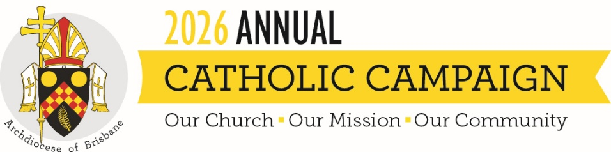
SUMMARY OF HOMILY FOR THE ANNUAL CATHOLIC CAMPAIGN 2026
“You are Peter, and on this rock I will build my Church,” says Jesus in this Sunday’s Gospel. Jesus reminds us that the Church is not something we simply receive, it is something we build together, by God’s grace.
In his homily video, Archbishop Shane explains that we build the Church whenever faith takes flesh in practical love: when compassion is offered to those who are struggling, when dignity is upheld, when the vulnerable are cared for, and when the future is prepared with attention and hope.
That is what we all strive to do every day as part of the Church across our Archdiocese. And it is why the Annual Catholic Campaign exists – to support five key ministries that provide care to those who need it most:
- The Mary MacKillop Brisbane Catholic School Access Fund, which helps ensure that children whose families are experiencing severe hardship have access to Catholic education.
- Holy Spirit Seminary, which prepares future Queensland priests for ministry, fostering faith, humility, collaboration and service.
- The Priests Foundation which ensures that priests who have spent their lives in service are themselves supported with care and dignity in their retirement.
- Centacare’s Pastoral Ministries, which offers support through domestic and family violence support, in hospitals and prisons, through counselling and through servicing families most in need.
- The Annual Grants Program which supports a range of parish and community initiatives through funding for grassroots programs that make a profound difference in local communities.
In his homily video, Archbishop Shane invites us not only to give, but to recognise ourselves as part of this shared mission. Together, may we allow God to keep building his Church among us.

