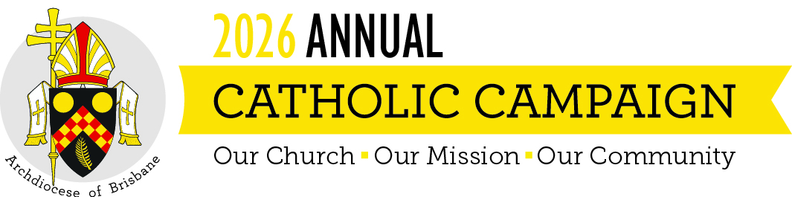

HOMILY FOR THE ANNUAL CATHOLIC CAMPAIGN 2026
Twenty-first Sunday in Ordinary Time (Year A), 23 August 2026
Readings: Isaiah 22:19–23; Romans 11:33–36; Matthew 16:13–20

In today’s Gospel, Jesus asks a question that is as personal now as it was then:
“Who do you say that I am?”
It is not asked of the crowds, but of the disciples — of those who walk with him, listen to him, and are learning what it means to be a disciple. Peter responds with a simple but profound confession of faith:
“You are the Christ, the Son of the living God.”
What follows is important. Jesus doesn’t stop with praise for Peter’s insight. He entrusts him with responsibility:
“You are Peter, and on this rock I will build my Church.”
Faith, in other words, is never just something we hold inwardly. It calls us outward — into relationship, into service, into shared responsibility for the life of the Church.
The first reading from Isaiah echoes this same movement. Authority is not given for self-interest or status, but for stewardship — for holding the key on behalf of others, for strengthening what has been entrusted. Saint Paul, in the reading from his letter to the Romans, reminds us why: everything comes from God, everything belongs to God, and everything finds its purpose in him.
Together, these readings remind us that the Church is not something we simply receive — it is something we build together, by God’s grace.
We build the Church whenever faith takes flesh in practical love: when compassion is offered to those who are struggling, when dignity is upheld, when the vulnerable are cared for, and when the future is prepared with attention and hope.
That is what we all strive to do every day as part of the Church across our Archdiocese. And it is what the Annual Catholic Campaign exists to support.
Through this campaign, we are able to sustain ministries that consistently, faithfully live out our Gospel commitment to provide concrete support to people.
Centacare accompanies individuals and families facing illness, imprisonment, violence, or crisis, offering a caring presence as well as practical support.
The Mary MacKillop Brisbane Catholic School Access Fund helps ensure that children whose families are under pressure have access to Catholic education at a critical moment in their lives.
The Annual Grants Program supports a range of parish and community initiatives — often small, local responses that make a profound difference.
The Priests Foundation ensures that priests who have spent their lives in service are themselves supported with care and dignity in their retirement.
And Holy Spirit Seminary prepares future priests for ministry, fostering faith, humility, collaboration and service, at a time when leadership in the Church matters deeply.
None of this is abstract. It is the Church becoming visible in tangible acts of care, formation, and accompaniment — the Church that Christ continues to build, not only on Peter’s profession on faith, but on the faith and generosity of God’s people.
So today is an invitation — not only to give, but to recognise ourselves as part of this shared mission. When we support the Church’s work, we are participating in something larger than ourselves. Following Peter’s example, we are saying, in our own way, “You are the Christ” — and allowing that profession of faith to shape how we live.
I invite you to support the Annual Catholic Campaign prayerfully and generously, and to consider a regular monthly gift of an amount that is meaningful to you.
As we come to the Eucharist, we place our lives once again into God’s hands, trusting in his wisdom and grace. May our faith, like Peter’s, be both confident and active, and may our generosity help ensure that the Church continues to be a place of hope, compassion, and service for those who need it most. Together, may we allow God to keep building his Church among us — here and now, and into the future.

