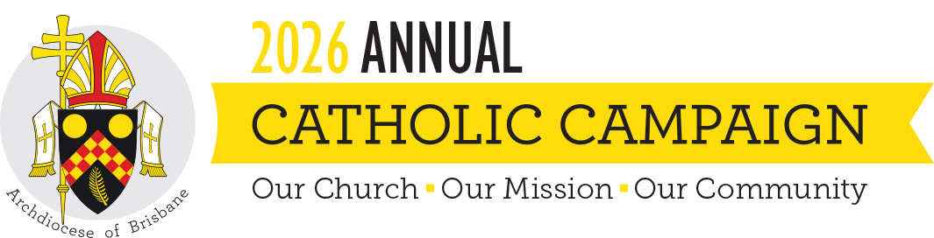
Social Media tiles for Annual Catholic Campaign

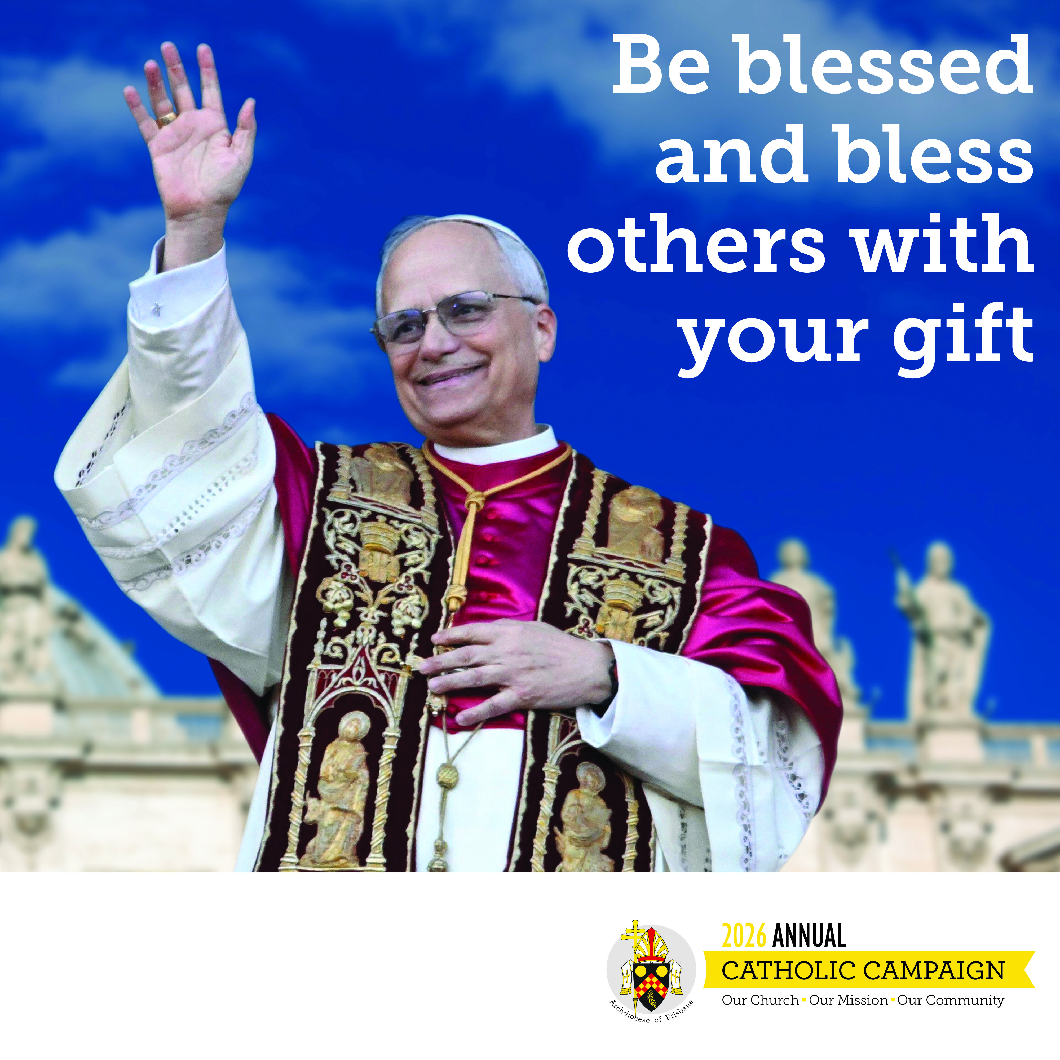 | Heading: Be blessed and bless others with your gift  Content: The Annual Catholic Campaign shows the power of our local Church. When we unite as one Archdiocesan family through our gifts, we support  ministries and people within our own neighbourhoods, reaching those in need, nurturing vocations, and participating in God’s own work.  Make your gift: catholiccampaign.com.au
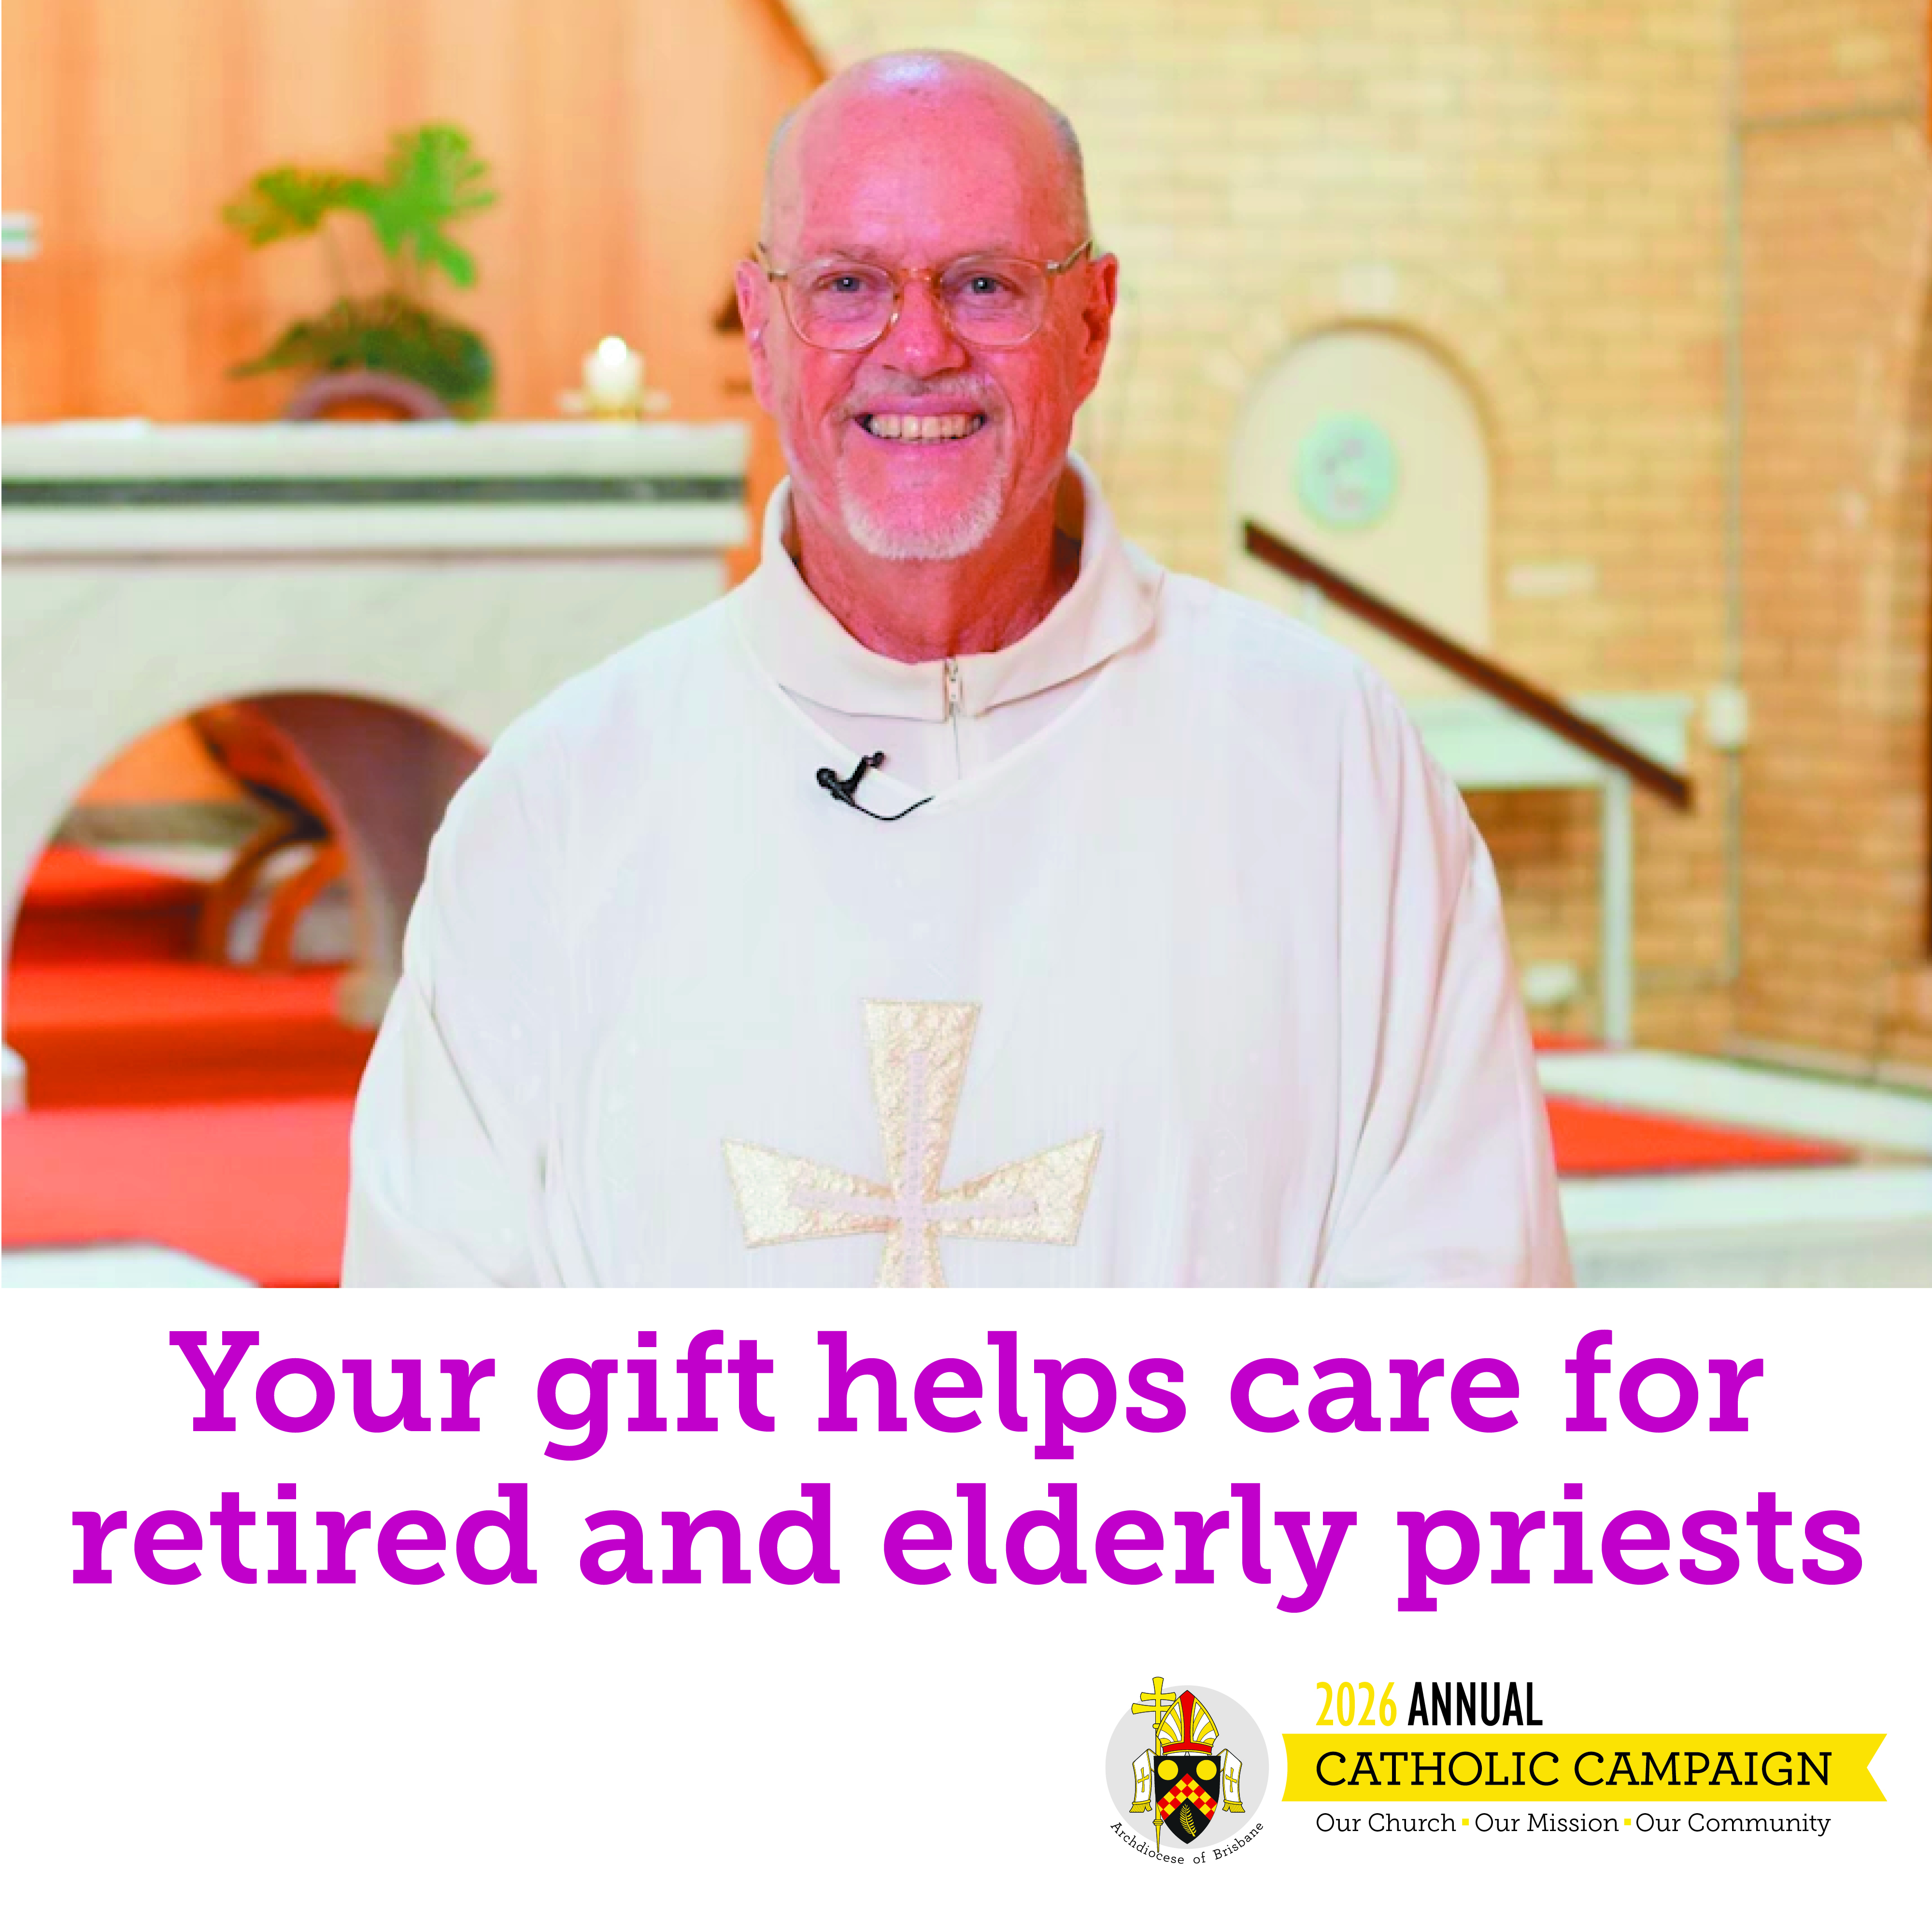 | Heading: Care for retired and elderly priests  Content: Your gift to The Priests Foundation ensures that priests who have spent their lives in service to God and our community are themselves supported  with care and dignity when they retire or become unwell.  Make your gift: catholiccampaign.com.au
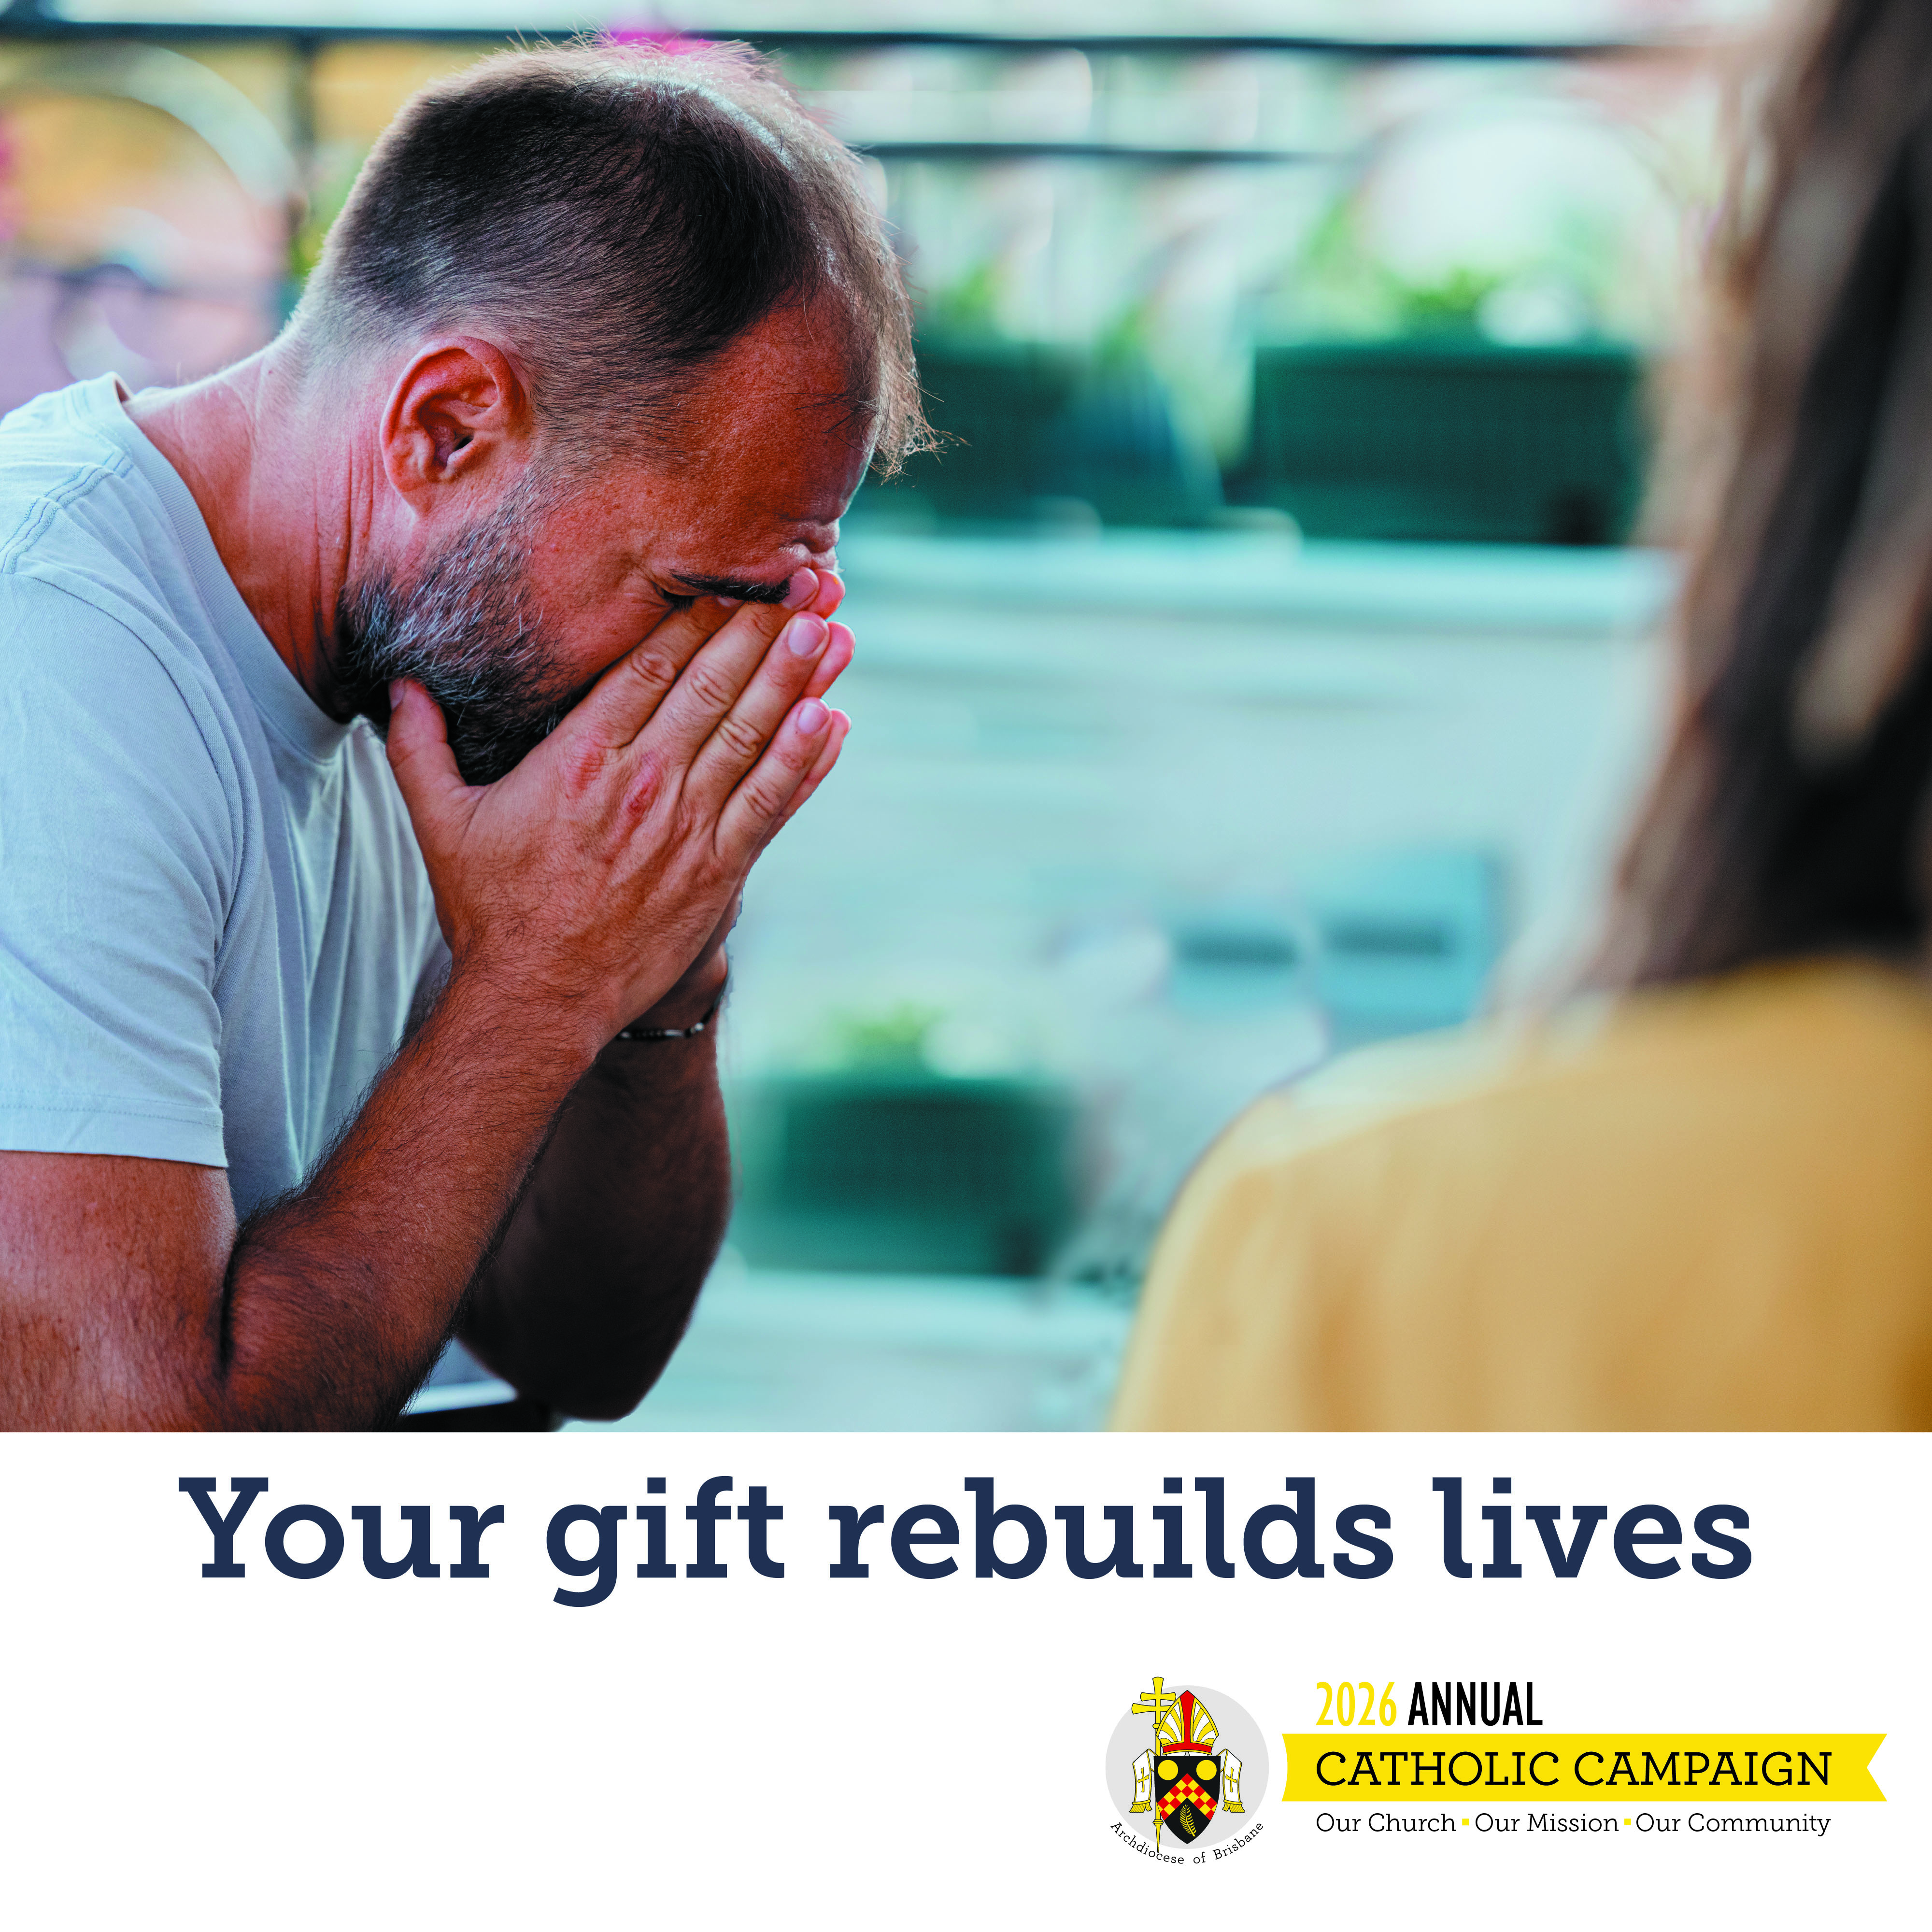 | Heading: Help Rebuild Lives  Content: Your generosity helps to protect some of the most vulnerable people in our community. Through Centacare, you provide safe refuge, practical support and hope to families and individuals at the moment they need our care most.  Make your gift: catholiccampaign.com.au
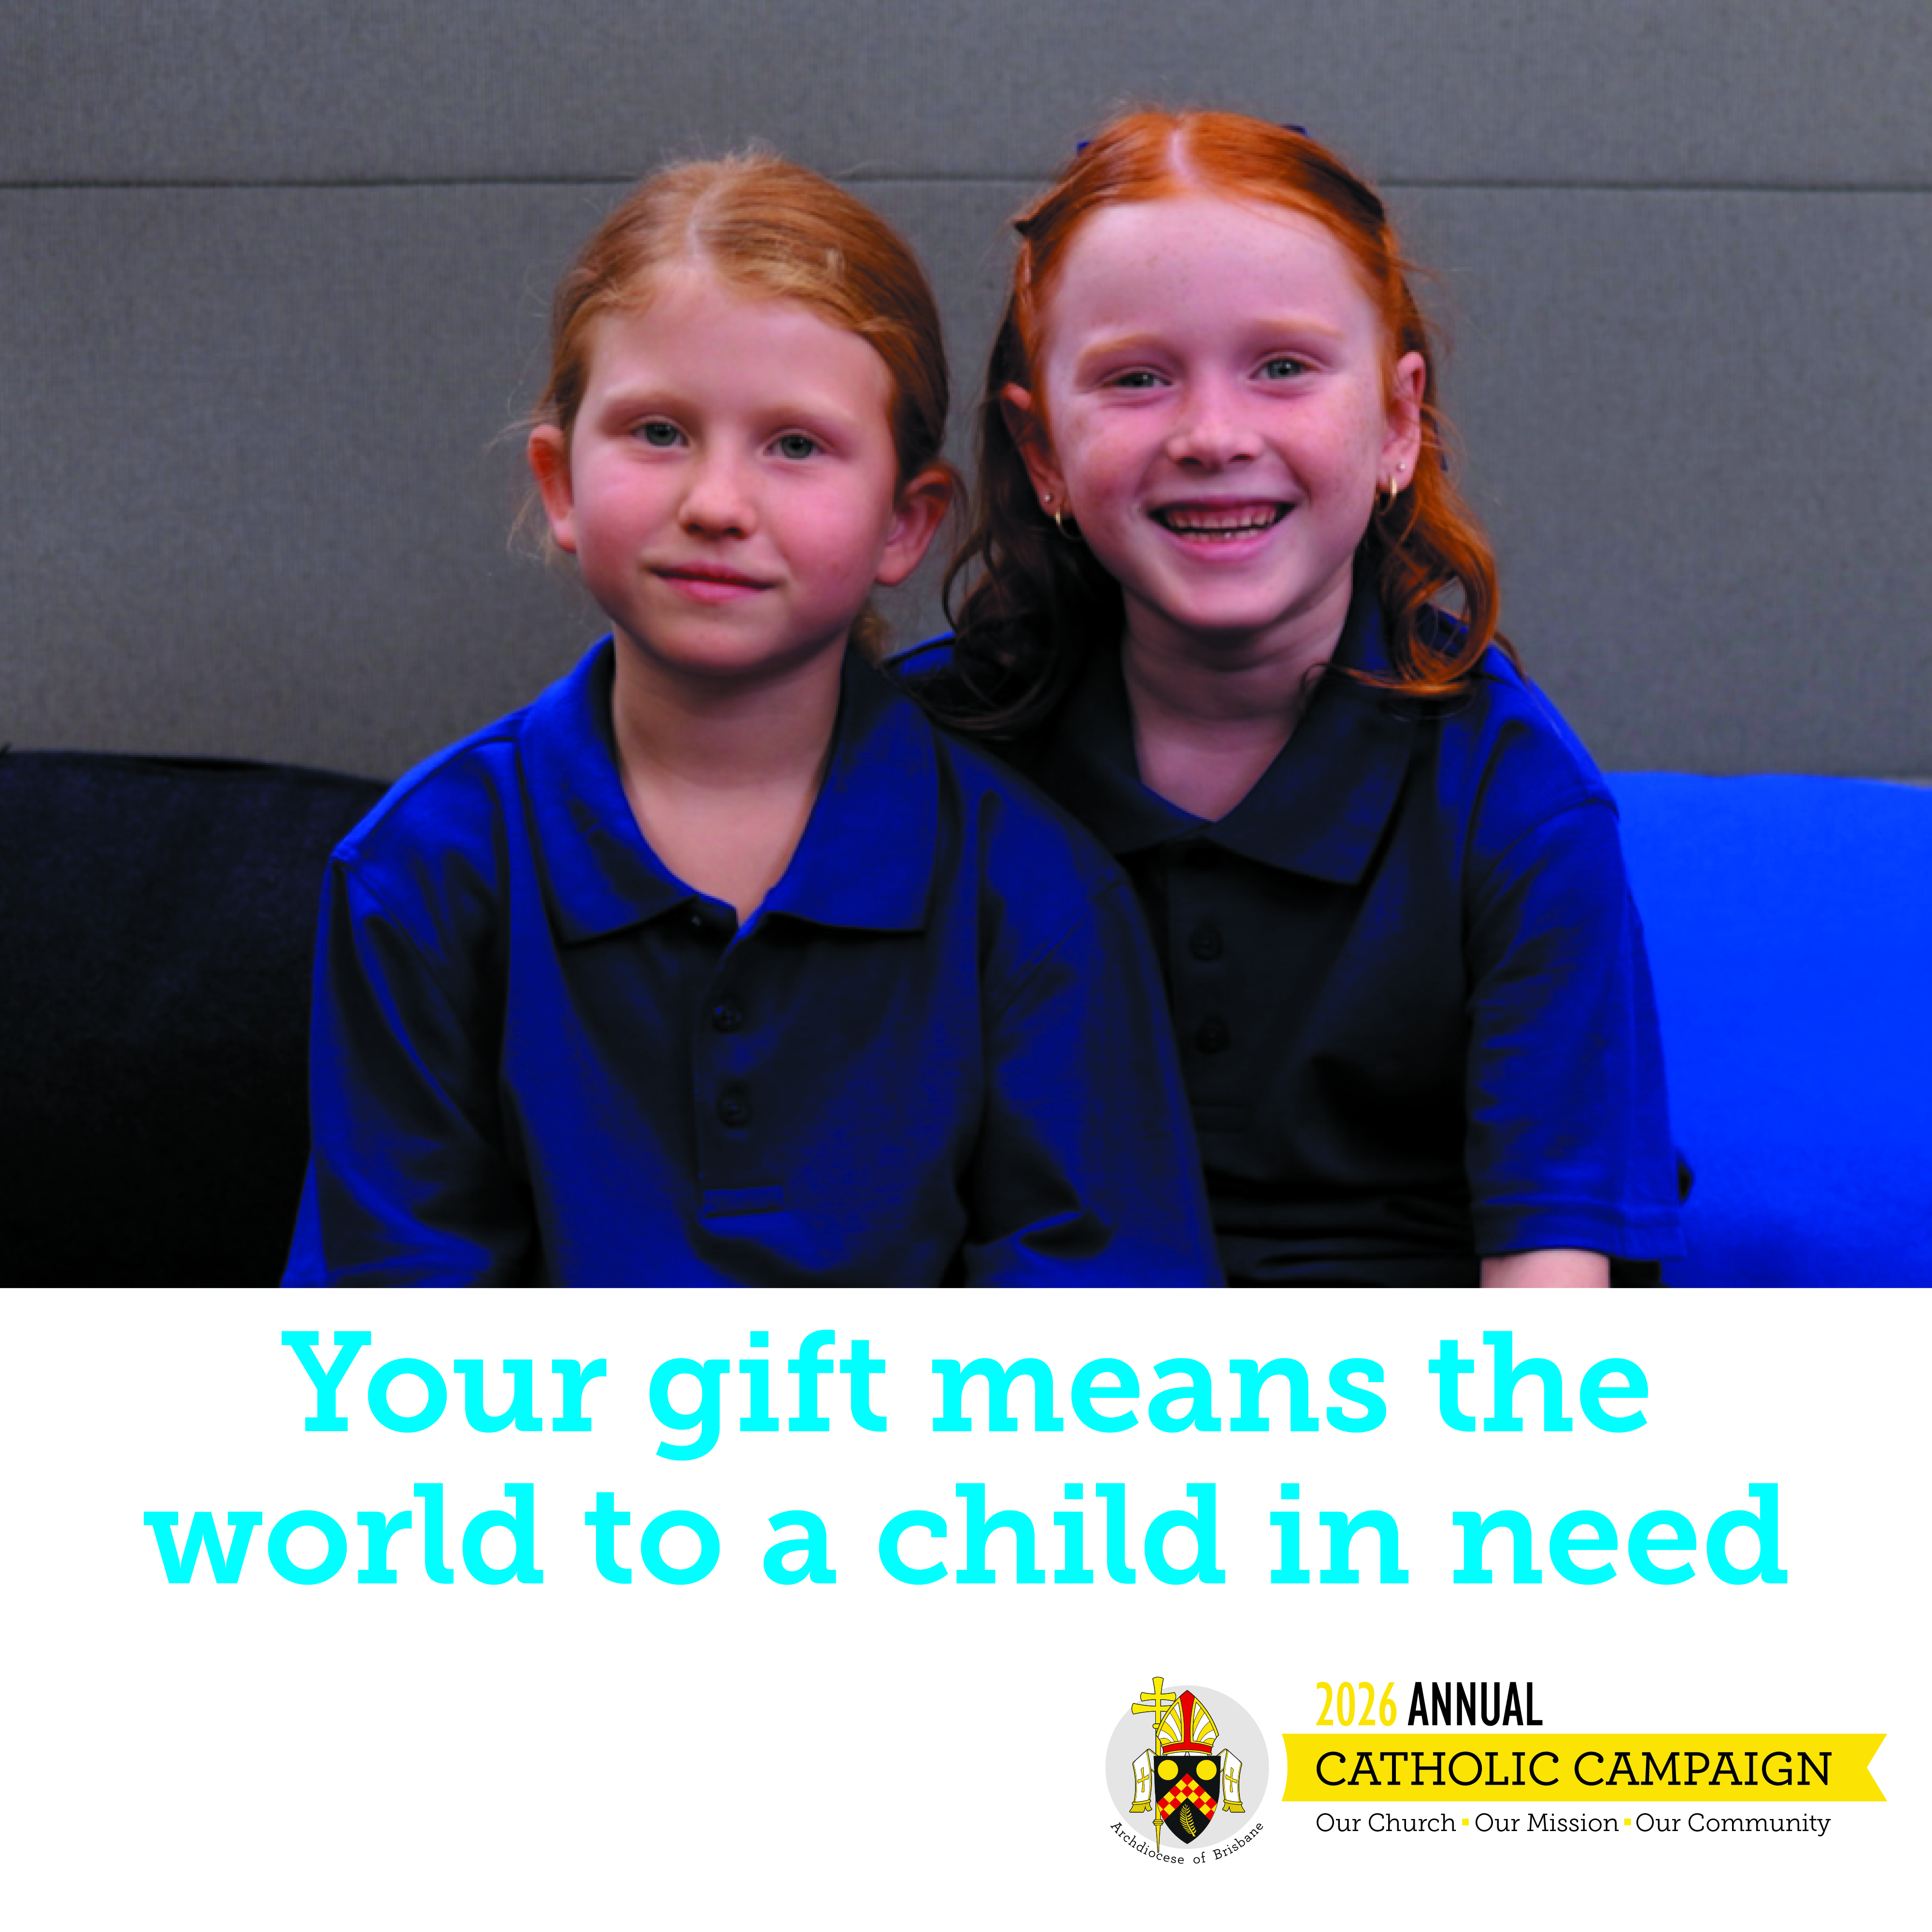 | Heading: Empower a child to dream  Content: Your gift to the Mary Mackillop Bursary Fund means the world to a child in need. Your gift helps struggling families and ensures that children in need can flourish in a holistic Catholic Education.  Make your gift: catholiccampaign.com.au
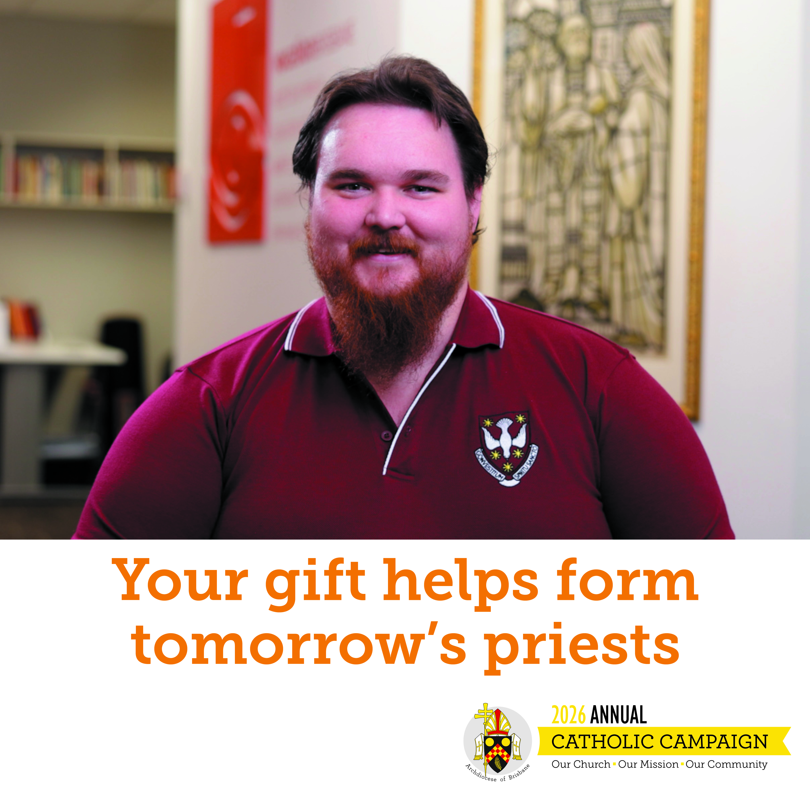 | Heading: Help form tomorrow’s priests  Content: With your gift, you help prepare future priests for ministry, fostering faith, humility, collaboration and service, at a time when leadership in the Church matters deeply.  Make your gift: catholiccampaign.com.au

