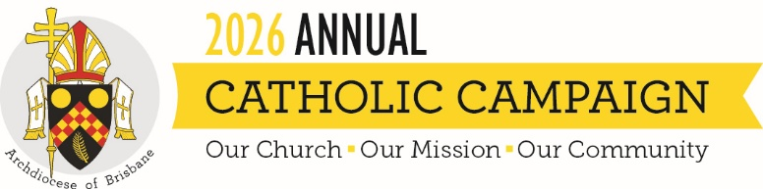
Campaign Weekend Script – for Seminarians
To be read on the weekend of 22-23 August 2026
The message below is provided as a guide and template for your use on Campaign weekend. You can either use it as is or tailor it to your parish. It is intended for seminarians placed in parishes to briefly announce the Campaign before each Mass held on the weekend of 22-23 August 2026.

Good morning/afternoon
During today’s Mass, we will hear an especially prepared homily from Archbishop Shane Mackinlay for the Annual Catholic Campaign.
As a seminarian, this Campaign means a lot to me. You will see Dylan in the campaign video, who is a fellow seminarian. With your support, Holy Spirit Seminary continues to be a place of formation for young men like Dylan and myself.
Of course, your support goes to more than just the seminary. When we unite as one Archdiocesan family through our gifts, we support ministries and people within our own neighbourhoods, reaching those in need, caring for elderly priests, helping families access a Catholic education, and participating in God's own work.
We need your support. When making a gift please put your donation inside the envelope [hold up brochure and show them how envelope is attached] so it remains separate from the parish collection. If you add your details to the envelope you will receive a tax receipt in the mail. You can also give online by scanning the QR code on the envelope, or going to catholiccampaign.com.au
Thank you for your generosity and for making sure our Church continues to be a source of hope, compassion, and service for those who need it most.

