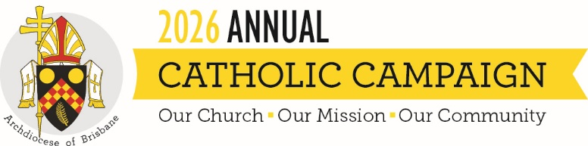
Campaign Weekend Script (Parish Priest or ACC Ambassador)
To be read on the weekend of 22-23 August 2026
The content below is intended to help you with content and ideas for announcing the campaign in your parish on campaign weekend. These are suggestions only, and you are free to change or add anything that you believe will resonate with your parishioners.

Good morning/afternoon!
This year has brought its own set of challenges and rewards, reminding us of the strength and resilience found through our faith. We have much to be thankful for as a parish. Out of all the things to be grateful for, I am most grateful for your continued support which makes a significant impact on the work that we do as one Church.
Today, we will hear an especially prepared homily from Archbishop Shane Mackinlay, to share the importance of the Annual Catholic Campaign and how we can continue to be blessed and bless others in our daily lives.
The Annual Catholic Campaign reminds us that we are part of the larger Church. Our parishes work together to support vital ministries and services. Funds raised will support ministries that directly impact this parish, such as:
- training future priests
- caring for elderly priests when they become frail and unwell
- helping struggling families access a Catholic education
- caring for those suffering physically and emotionally in our local community
- supporting community-driven ministries that make a profound impact in our own parish and immediate social groups
I encourage you to support the Annual Catholic Campaign as there are many who need our care, and this campaign reaches out to those who need our support most.
When making your gift, please put your donation inside the envelope provided [hold up brochure and show them how envelope is attached] so it remains separate from the parish collection. If you add your details to the envelope, you will receive a tax receipt in the mail. Of course, if you prefer, you can also give online by scanning the QR code on the envelope, or going to catholiccampaign.com.au.
Over the past years, our parish has given generously and together we have made a lasting impact on the lives of so many people in our community. Thank you for your faithful generosity and for making sure our Church continues to be a source of hope, compassion, and service for those who need it most.

