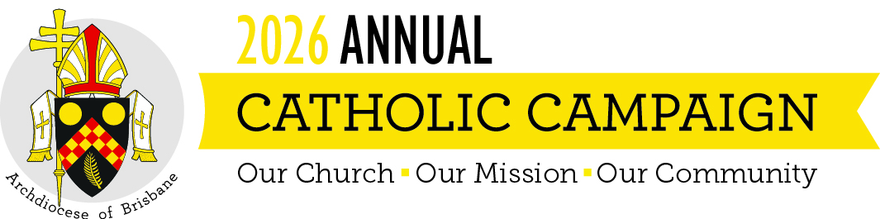
Pre Campaign Weekend Script
To be read weekend 15 – 16 August 2026
Below are some suggested words to introduce this year’s Campaign to your parishioners. It can be read by your parish ambassador or the parish priest. Feel free to adjust, edit or modify as you see fit.

Good morning/afternoon!
Next weekend, our parish will support the Annual Catholic Campaign. This special campaign brings together all the parishes of the Archdiocese of Brisbane, to provide support for local ministries and care for people in need in our own communities.
Funds raised will directly impact our parish and local communities. The Campaign supports the holistic formation of our future priests, cares for our elderly and retired priests, provides children in need with access to a Catholic education and gives hope to those in our community who are suffering physically and emotionally.
Please do take a Campaign brochure and giving envelope [hold up brochure and show them how envelope is attached] with you when you go today. You can either pop it in the mail or return it here next week. Of course, if you prefer, you can also fill it in today and place it in the collection, or scan the QR code on the envelope to make your gift online.
Thank you and may God bless you for your generosity and faithfulness.

