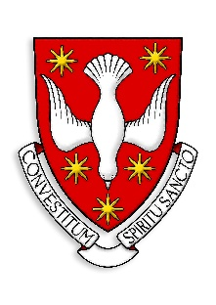

SCRIPT FOR PRIESTS/SEMINARIAN/AMBASSADORS TO READ DURING MASS:

Think for a moment about the priests who have mattered in your life. The one who baptised your child. Who sat with you in a hospital room. Who knew your name and said it with care.

Each of those men began their journey at a seminary. And for Queensland, that place is our provincial seminary in Brisbane.

Right now, nineteen young men who have heard God’s call and said yes to it, knowing full well what that yes will cost years of study, deep self-examination and a life given entirely in service to others.

Today's priest will often shepherd not one parish, but several, leading multiple communities, multiple schools, with fewer colleagues alongside him. The demands are greater than ever. The need for strong, well-formed priests has never been more urgent.

Holy Spirit Seminary needs our support to keep doing this work. Your gift, of whatever size you are able to give, helps provide the accommodation and the pastoral formation that turns a young man's calling into a life of faithful service.

You may not be called to the priesthood. But you can be part of forming the men who are.
Please give generously today. And please pray for our seminarians that God strengthens them for the road ahead, and that this community plays its part in sending them on their way.

