MASS OF THANKSGIVING
IN HONOUR OF
ETERNAL GUARDIANS &
QUINN MEDAL RECIPIENTS




SOLEMNITY OF ALL SAINTS
SATURDAY, 1ST NOVEMBER 2025

CELEBRANT
MOST REVEREND SHANE MACKINLAY
ARCHBISHOP OF BRISBANE

MUSICIANS
ST STEPHEN’S CATHEDRAL SCHOLA DIRECTED BY CHRISTOPHER TRIKILIS

NOTE:
PLEASE ENSURE YOU HAVE SWITCHED YOUR MOBILE PHONE OFF OR ONTO SILENT SO THAT THE SACRED NATURE
OF OUR WORSHIP IS NOT DISTURBED.

INTROIT Psalm 32

Gaudeamus omnes is Domino, diem festum celebrantes sub honore Sanctorum omnium: de quorum solemnitate gaudent angeli, et collaudant Filium Dei.
Let us all rejoice in the Lord as we celebrate this feast day in honour of all the saints; it is a solemnity which causes the Angels to rejoice, and to praise together the Son of God.

PROCESSIONAL HYMN CWBII 439

For all the saints who from their labours rest,
who to the world their faith in you confessed,
your name, O Jesus, be for ever blest.
Alleluia! Alleluia!

You were their rock, their fortress and their might;
their noble captain in the well fought fight;
and in the darkest hour their one true light.
Alleluia! Alleluia!

So may your people, faithful, true, and bold,
fight like the saints who bravely fought of old,
and win, with them, the victor’s crown of gold.
Alleluia! Alleluia!

INTRODUCTORY RITES
Archbishop In the name of the Father, and of the Son, and of the Holy Spirit.
All Amen.

Archbishop Peace be with you.
All And with your spirit.

PENITENTIAL RITE
Archbishop Brothers and sisters,
let us acknowledge our sins, and so prepare ourselves to celebrate the sacred mysteries.

All I confess to almighty God,
and to you, my brothers and sisters,
that I have greatly sinned
in my thoughts and in my words,
in what I have done, and in what I have failed to do;
through my fault, through my fault,
through my most grievous fault;
therefore I ask blessed Mary ever-Virgin,
all the Angels and Saints, and you, my brothers and sisters,
to pray for me to the Lord our God.

Archbishop May almighty God have mercy on us, forgive us our sins and bring us to everlasting life.
All Amen.

KYRIE ELEISON
The Choir sings the Kyrie Eleison
from Missa Brevis in D Minor K.65
– Wolfgang Amadeus Mozart (1756-1791)

Kyrie Eleison. Lord, have mercy.
Christe Eleison. Christ, have mercy.
Kyrie Eleison. Lord, have mercy.

GLORIA

The Choir sings the Gloria in Excelsis from
Missa Brevis in D Minor K.65
– Wolfgang Amadeus Mozart (1756-1791)

Glory to God in the highest.
And on earth peace to people of good will.
We praise you. We bless you.
We adore you. We glorify You.
We give you thanks for your great glory.
Lord God, heavenly King,
O God Almighty Father.
Lord Jesus Christ, the Only-begotten Son.
Lord God, Lamb of God, Son of the Father:
You take away the sins of the world, have mercy on us.
You take away the sins of the world, receive our prayer.
You are seated at the right hand of the Father,
have mercy on us.
For you alone are the Holy One.
You alone are the Lord.
You alone are the Most High, Jesus Christ,
With the Holy Spirit in the glory of God the Father.
Amen.

COLLECT
Archbishop Let us pray.
Almighty ever-living God,
by whose gift we venerate in one celebration
the merits of all the Saints,
bestow on us, we pray,
through the prayers of so many intercessors,
an abundance of the reconciliation with you
for which we earnestly long.
Through our Lord Jesus Christ, your Son,
who lives and reigns with you in the unity of the Holy Spirit,
God, for ever and ever.
All Amen.

LITURGY OF THE WORD

FIRST READING Mr Derek Pingel, Eternal Guardian
Revelation 7:2-4,9-14

I, John, saw another angel come up from the East, holding the seal of the living God. He cried out in a loud voice to the four angels who were given power to damage the land and the sea,
"Do not damage the land or the sea or the trees until we put the seal on the foreheads of the servants of our God."
I heard the number of those who had been marked with the seal,
one hundred and forty-four thousand marked from every tribe of the children of Israel.

After this I had a vision of a great multitude, which no one could count, from every nation, race, people, and tongue. They stood before the throne and before the Lamb, wearing white robes and holding palm branches in their hands. They cried out in a loud voice:
"Salvation comes from our God, who is seated on the throne,
and from the Lamb."

All the angels stood around the throne and around the elders and the four living creatures. They prostrated themselves before the throne,
worshiped God, and exclaimed:
"Amen. Blessing and glory, wisdom and thanksgiving, honor, power, and might be to our God forever and ever. Amen."
Then one of the elders spoke up and said to me,
"Who are these wearing white robes, and where did they come from?"
I said to him, "My lord, you are the one who knows."
He said to me, "These are the ones who have survived the time of great distress; they have washed their robes and made them white in the Blood of the Lamb."

The word of the Lord.

All Thanks be to God.

RESPONSORIAL PSALM (Sung) Ps 24:1bc-2, 3-4ab, 5-6
Response Lord, this is the people that longs to see your face.

The Lord's are the earth and its fullness;
the world and those who dwell in it.
For he founded it upon the seas
and established it upon the rivers. Response

Who can ascend the mountain of the Lord?
or who may stand in his holy place?
One whose hands are sinless, whose heart is clean,
who desires not what is vain. Response

He shall receive a blessing from the Lord,
a reward from God his savior.
Such is the race that seeks him,
that seeks the face of the God of Jacob. Response

SECOND READING Mrs Jenny Nijman, Eternal Guardian
1 John 3:1-3

Beloved:
See what love the Father has bestowed on us that we may be called the children of God.
Yet so we are.
The reason the world does not know us is that it did not know him.
Beloved, we are God's children now;
what we shall be has not yet been revealed.
We do know that when it is revealed we shall be like him,
for we shall see him as he is.
Everyone who has this hope based on him makes himself pure,
as he is pure.

The word of the Lord.

All Thanks be to God.

GOSPEL ACCLAMATION
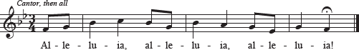
v. Come to me, all you who labor and are burdened,
And I will give you rest, says the Lord.

GOSPEL

Matthew 5:1-12

When Jesus saw the crowds, he went up the mountain, and after he had sat down, his disciples came to him. He began to teach them, saying:

"Blessed are the poor in spirit,
for theirs is the Kingdom of heaven.
Blessed are they who mourn,
for they will be comforted.
Blessed are the meek,
for they will inherit the land.
Blessed are they who hunger and thirst for righteousness,
for they will be satisfied.
Blessed are the merciful,
for they will be shown mercy.
Blessed are the clean of heart,
for they will see God.
Blessed are the peacemakers,
for they will be called children of God.
Blessed are they who are persecuted for the sake of righteousness,
for theirs is the Kingdom of heaven.
Blessed are you when they insult you and persecute you
and utter every kind of evil against you falsely because of me.
Rejoice and be glad,
for your reward will be great in heaven."
The Gospel of the Lord.

All Praise to you, Lord Jesus Christ.

HOMILY The Archbishop

THE APOSTLES’ CREED

All I believe in God, the Father almighty,
Creator of heaven and earth,
and in Jesus Christ, his only Son, our Lord,
who was conceived by the Holy Spirit,
born of the Virgin Mary, suffered under Pontius Pilate,
was crucified, died and was buried;
he descended into hell;
on the third day he rose again from the dead;
he ascended into heaven,
and is seated at the right hand of God the Father almighty;
from there he will come to judge the living and the dead.

I believe in the Holy Spirit, the holy catholic Church, the communion of saints, the forgiveness of sins,
the resurrection of the body, and life everlasting.
Amen.

PRAYERS OF INTERCESSION FOR THE ETERNAL GUARDIANS
Ms Mary Naughton, Quinn Medal recipient

Archbishop Sisters and brothers, in the power of the Holy Spirit we offer our prayers for all who through their generosity, compassion and love of God enable the work of the Church to be sustained and to grow.

Reader We praise and bless you, O God, for all the gifts of your grace,

mercy and love.
All Blessed be God forever.

We praise and bless you for the riches of creation you have bestowed upon us.
All Blessed be God forever.

We praise and bless you for the communities who continue the work of the Gospel.
All Blessed be God forever.

We praise and bless you for the generous hearts who minister in the local Church.
All Blessed be God forever.

We praise and bless you for the Eternal Guardians who carry our mission into the future.
All Blessed be God forever.

We praise and bless you for Jesus, your Son, who walks with us on our journey of life.
All Blessed be God forever.

We praise and bless you for your Holy Spirit who guides us into eternal peace and joy.
All Blessed be God forever.

Archbishop Almighty God, Father, Son and Holy Spirit, we place our prayers humbly before you. Accept our lives, our service and our loving compassion which we offer through your Son, Jesus, who is Lord for ever and ever.

All Amen.

LITURGY OF THE EUCHARIST

PREPARATION OF THE GIFTS
Mr Brian and Mrs Judy Shepherd, Quinn Medal recipients

OFFERTORY MOTET
During the Preparation of the Offerings, the Schola sings:
‘O quam gloriosum est regnum’
- Tomas Luis de Victoria (1548-1611)

O quam gloriosum est regnum,
in quo cum Christo gaudent omnes Sancti! Amicti stolis albis, sequuntur Agnum, quocumque ierit.

O how glorious is the kingdom in which all the saints rejoice with Christ, clad in robes of white they follow the Lamb wherever he goes. (Rev 7:9)

PRAYER OVER THE OFFERINGS (ALL SING)
SANCTUS MASS XVIII
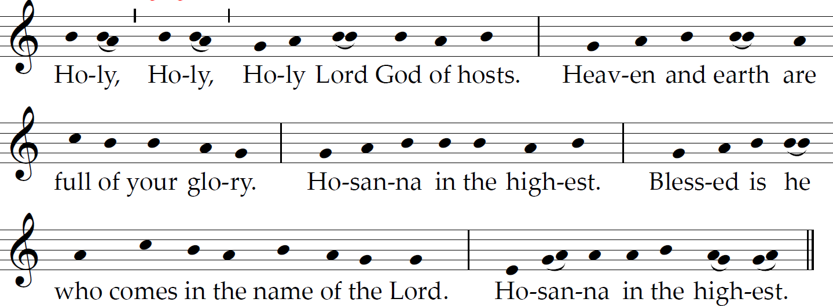

EUCHARISTIC PRAYER

MEMORIAL ACCLAMATION (ALL SING) ICEL #1
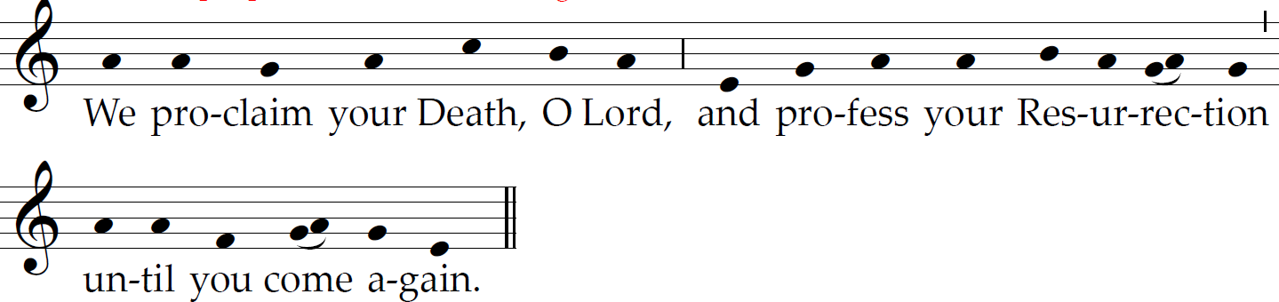

All Amen.

THE LORD’S PRAYER (All sing)

AGNUS DEI
The Choir sings the Agnus Dei
from Missa Brevis in D Minor K.65
– Wolfgang Amadeus Mozart (1756-1791)

Agnus Dei, qui tollis peccata mundi, miserere nobis.
Agnus Dei, qui tollis peccata mundi, miserere nobis.
Agnus Dei, qui tollis peccata mundi, dona nobis pacem.

Lamb of God, you take away the sins of the world, have mercy on us. Lamb of God, you take away the sins of the world, have mercy on us. Lamb of God, you take away the sins of the world, grant us peace.

FRACTION RITE

Archbishop Behold the Lamb of God.
Behold him who takes away the sins of the world. Blessed are those called to the supper of the Lamb.

All Lord, I am not worthy
that you should enter under my roof,
but only say the word,
and my soul shall be healed.

HOLY COMMUNION

COMMUNION MOTET Text Attr. POPE INNOCENT IV

During Communion, the Schola sings
‘Ave Verum Corpus’ Op.1 by Alexandre Guilmant (1833-1911)

Ave, verum corpus natum de Maria Virgine: vere passum, immolatum in cruce pro homine: cuius latus perforatum fluxit aqua et sanguine: esto nobis praegustatum, in mortis examine.
O Jesu dulcis, O Jesu pie, O Jesu Fili Mariae.
O Jesu Fili Mariae.
Hail the true body,
born of the Virgin Mary:
You who truly suffered and were sacrificed on the cross for the sake of man. From whose pierced flank flowed water and blood:
Be a foretaste for us (of the Heavenly Banquet) in the trial of death.
O sweet Jesus, O holy Jesus,
O Jesus, Son of Mary.
O Jesus, Son of Mary.

COMMUNION HYMN CWBII 164
Soul of my Saviour, sanctify my breast:
body of Christ, be thou my saving guest;
blood of my Saviour, bathe me in thy tide,
wash me with water flowing from thy side.

Strength and protection may thy Passion be;
O blessed Jesus, hear and answer me;
deep in thy wounds, Lord, hide and shelter me;
so shall I never, never part from thee.

Guard and defend me from the foe malign,
in death’s dread moments make me only thine;
call me and bid me come to thee on high,
where I may praise thee with thy saints for aye.

PRAYER AFTER COMMUNION
Archbishop Let us pray.
As we adore you, O God, who alone are holy
and wonderful in all your Saints,
we implore your grace
so that, coming to perfect holiness in the fullness of your love,
we may pass from this pilgrim table
to the banquet of our heavenly homeland.

Through Christ our Lord.
All Amen.

THE CONCLUDING RITES

SOLEMN BLESSING
Archbishop May God, the glory and joy of the Saints who has caused you to be strengthened by means of their outstanding prayers, bless you with unending blessings
All Amen

Archbishop Freed through their intercession from present ills
and formed by the example of their holy way of life,
may you be ever devoted to serving God and your neighbour.
All Amen

Archbishop So that, together with all, you may possess the joys of the homeland
where Holy Church rejoices that her children are admitted
in perpetual peace to the company of the citizens of heaven.
All Amen

Archbishop And may the blessing of almighty God,
the Father, and the Son, and the Holy Spirit
come down upon you and remain with you forever.
All Amen

Archbishop Go in peace, glorifying the Lord by your life
All Thanks be to God

RECESSIONAL HYMN CWBII 351

By ev’ry nation, race and tongue,
worship and praise be ever sung; praise the Father: Alleluia!
For pardoned sin, death overcome,
And hopes that live beyond the tomb:
Alleluia, alleluia! Alleluia, alleluia, alleluia!

Saints who on earth have suffered long
for Jesus’ sake enduring wrong, ever faithful: Alleluia!
Where faith is lost in sight,
rejoice and sing with never wearied voice:
Alleluia, alleluia! Alleluia, alleluia, alleluia!

Let earth and air and sea unite
to celebrate his glorious might, their creator: Alleluia!
Sun, moon and stars in endless space
echo the song of ev’ry race:
Alleluia, alleluia! Alleluia, alleluia, alleluia!

Acknowledgements
Excerpts from the English translation and chants of The Roman Missal © 2010, International Commission on English in the Liturgy Inc (or ICEL). All rights reserved.
The English translation of the Responsorial Psalm response, Alleluia and Gospel verse from The Lectionary for Mass © 1969, 1981, 1997. ICEL. All rights reserved.
Scripture quotations from The Jerusalem Bible © 1966 by Darton, Longman & Todd Ltd and Doubleday and Company Ltd. All rights reserved. Used by permission.
Excerpts from the English translation and chants of The Roman Missal © 2010, ICEL. All rights reserved.
Resp Ps. Psalm 24 Music: Joseph Gelineau SJ. All rights reserved. Used with permission. One License #A-640361
For all the saints Text: William Walsham How 1823-1897; Tune: SINE NOMINE Ralph Vaughan Williams 1872-1958; Used with permission. ONE LICENSE #A-640361
Soul of my Saviour Text: Anima Christi attr. Pope John XXII 1249-1334 trans. anon. Tune: ANIMA CHRISTI; William Joseph Maher 1832-1877. Used with permission. ONE LICENSE #A-640361
By ev'ry nation, race and tongue Text: Hereford Brooke George 1838-1910; Tune: LASST UNS ERFREUEN melody from Auserlesen Catholische Geistliche Kirchengesäng Cologne, 1623, Arr. & harm. Ralph Vaughan Williams 1872-1958; Used with permission. ONE LICENSE #A-640361

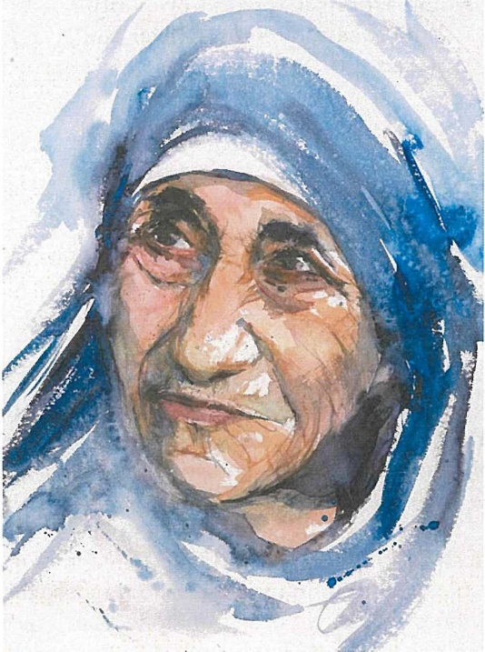

“I alone cannot change the world, but I can cast a stone across the waters to create many ripples."

Saint Teresa of Kolkata

For more information on how you can become an Eternal Guardian of your faith please visit
www.catholicfoundation.org.au/eternalguardians

