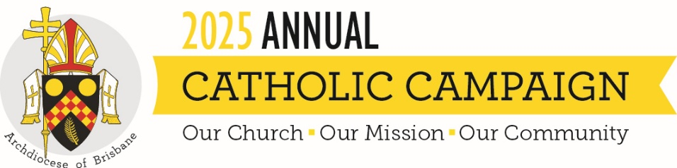
SUMMARY OF HOMILY FOR THE ANNUAL CATHOLIC CAMPAIGN 2025
“Strive to enter by the narrow door,” says Jesus in this Sunday’s Gospel. These words challenge us to reflect on the burdens we carry - pride, fear, hardship, injustice - that might stop us from entering the Kingdom of God. The Gospel reminds us that all are invited to the feast, but the path is narrow and demands that we lay down whatever weighs us down.
In his homily video, Archbishop Mark explains that some people carry burdens like poverty, violence, or illness. Things they did not choose and cannot carry alone. Others may be burdened by judgement or exclusion, turning away those Jesus came to welcome. The Church, then, must be a community that helps to lift burdens, not add to them.
This is where the Annual Catholic Campaign comes in. The Campaign supports five key ministries that help people from all walks of life move closer to the “narrow door”:
- The MacKillop Brisbane Catholic School Access Fund, providing education to children in need
- Holy Spirit Seminary, forming future priests to serve our communities
- The Priests Foundation, caring for our retired priests
- Centacare’s Pastoral Ministries, offering support in hospitals, prisons, counselling and family services
- The Annual Grants Program, seeding parish and community projects in areas like youth ministry and care for the poor
By supporting this Campaign, we help lift the weight from others’ shoulders, and even our own. In doing so, we live out the Gospel invitation to make room at the feast of the Kingdom for all God’s people.

