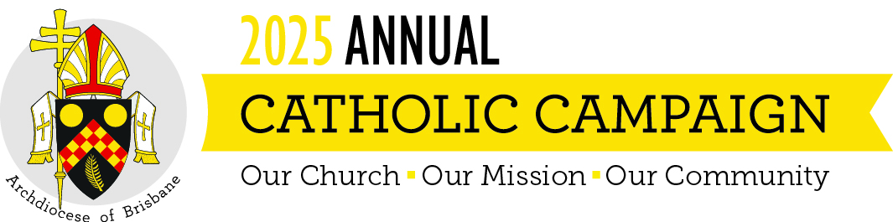
Pre Campaign Weekend Script
To be read weekend 16 – 17 August 2025
Below are some suggested words to introduce this year’s Campaign to your parishioners. It can be read by your parish ambassador or the parish priest. Feel free to adjust, edit or modify as you see fit.

Good morning/afternoon,
Next weekend, our parish will support the Annual Catholic Campaign. This special campaign brings together all the parishes of the Archdiocese, to provide care and support for local ministries and people in need in our own communities.
Funds raised will support ministries that directly impact this parish. The Campaign supports training future priests, caring for our elderly and retired priests, giving local families in dire need access to a Catholic education and caring for those suffering physically and emotionally in our community.
Please do take a Campaign brochure and giving envelope [hold up brochure and show them how envelope is attached] with you when you go today. You can either pop it in the mail or return it next week. Of course, if you prefer, you can also fill it in today and place it in the collection, or scan the QR code on the envelope to make your gift online.
Thank you and God bless.

