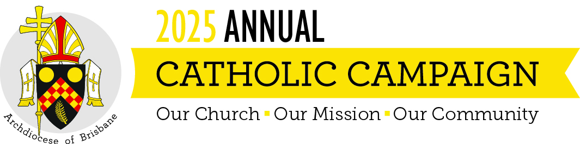

HOMILY FOR THE ANNUAL CATHOLIC CAMPAIGN 2025
Twenty-first Sunday of Ordinary Time Year C
Isaiah 66:18-21; Hebrews 12:5-7, 11-13; Luke 13:22-30

“Strive to enter by the narrow door “, says Jesus, “for many will try to enter and will not be able”. Now that can sound daunting, because it seems to say that many won’t make it. But Jesus doesn’t say they will be excluded; he says they won’t be able to enter by the narrow door. The poet Wendell Berry tells us why: “Because”, he says, “you cannot pass beyond it burdened” (Sabbath V, 1985). If you’re carrying a big burden, you simply can’t pass through the narrow door. Therefore, if we want to pass through the narrow door, we have to leave our burdens behind or we need someone to lift them from us.
All are welcome to pass through the door, as the prophet Isaiah makes clear. “I am coming to gather all tongues and nations”, he says in God’s name – not just one or some but all. Jesus echoes the prophet when he says that “people will come from east and west, from north and south” to the feast in the Kingdom of God. So it’s a feast that lies beyond the narrow door; and all are called to the feast. But they can come to the feast only through the narrow door; and they can’t pass through the narrow door until they’ve left their burdens behind.
So what are the burdens we have to leave behind? For some of us it may be the pride and fear which lead us to exclude people, to shut them out because we judge them unworthy or dangerous. “Will only a few be saved?” Jesus is asked. This would’ve been a popular perception: that only a few virtuous people would be saved and most people who were sinners wouldn’t be saved. But this isn’t the way Jesus sees things. He knocks down the walls built by pride and fear, and he opens a vision of a feast to which all are called and from which there will be some surprising exclusions of those burdened by pride and fear. The Church is called to do the same, but that will require the kind of discipline of which the Letter to the Hebrews speaks: “The Lord disciplines those he loves”, we are told. “Endure trials for the sake of discipline”. Unburdening is hard work; it takes real discipline.
Other people, usually those excluded by the proud and fearful, are burdened by poverty, injustice, violence, frailty, disability or whatever; and they need to have these burdens lifted from them before they can pass through the narrow door. That’s a crucial task of the Church: not to impose still heavier burdens but to lift the burdens that exclude many people from the feast. That too will require discipline, so that we can come to the feast ourselves.
The Annual Catholic Campaign is all about lifting the burdens so that as many as possible can pass through the narrow door and come to the feast.
The Campaign focuses on five of these works:
- The MacKillop Brisbane Catholic School Fund which helps Catholic children from families in difficulty to have a Catholic education. It seeks to do now what St Mary MacKillop did years ago.
- Holy Spirit Seminary which trains the priests of the future to be missionaries of mercy, going in search of the burdened and the lost whoever and wherever they may be.
- The Priests Foundation which supports the pastors of the Church who have passed responsibility to others but who are still a vital part of the Church’s life.
- Centacare’s Pastoral Ministries which reach out to lift the burdens through services like psychiatric counselling, family support, hospital chaplaincy and prison ministry.
- Finally there is the Annual Grants Program which provides start-up support to creative grassroots ministries in the parishes and wider Catholic community. Each year grants are made to a wide range of initiatives in areas as diverse as service of the poor, youth ministry, faith education, and the teaching of prayer. The grants are not large but the fruits of these works are.
So this morning, I ask you to support the Annual Catholic Campaign – perhaps by making a regular monthly gift of an amount that means something to you, something more than loose change. Every dollar given will be carefully spent, I promise you – and spent for the purposes I’ve mentioned or the purposes which you specify when making the gift. The money isn’t given to the Archdiocese; it’s given to those we serve. It’s not our money; it’s their money. That’s why we’re very careful about how it’s spent.
The Annual Catholic Campaign will help lift the burden from our own shoulders and from the shoulders of many others. It’s a way of ensuring that as many as possible are able to pass through the narrow door and come to the feast of the Kingdom which God has prepared for all.

