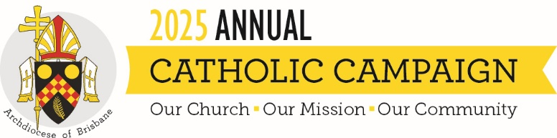
Campaign Weekend Script (Parish Priest or ACC Ambassador)
The content below is intended to help you with content and ideas for announcing the campaign in your parish on campaign weekend. These are suggestions only, and you are free to change or add anything that you believe will resonate with your parishioners.

Good morning/afternoon
This year has brought its own set of challenges and rewards, reminding us of the strength and resilience found through our faith. Despite the obstacles, we have much to be thankful for, and the continued support from our community makes a significant impact on the good works of the Church.
Today, we will hear a specially prepared homily from Archbishop Mark Coleridge, to share the importance of the Annual Catholic Campaign, and how we can continue to be the answer to someone’s prayer in our daily lives.
There are many who need our care, and this campaign reaches out to those who need our support most. I encourage you to support it this year.
The Annual Catholic Campaign reminds us that we are part of the larger Church. Our parishes work together to support vital ministries and services. Funds raised will support ministries that directly impact this parish, such as:
- training future priests,
- caring for elderly priests when they become frail and unwell,
- helping struggling families access a Catholic education and
- caring for those suffering physically and emotionally in our local community.
- There is also the option to make a non-tax-deductible gift to help fund grassroots ministry.
When making your gift, please put your donation inside the envelope provided [hold up brochure and show them how envelope is attached] so it remains separate from the parish collection. If you add your details to the envelope you will receive a tax receipt in the mail.
Of course, if you prefer, you can also give online by scanning the QR code on the envelope, or going to catholiccampaign.com.au
Over the past years, our parish has given generously and together we have made a lasting impact on the lives of so many people in our community.
Thank you for your generosity and for making sure our Church is here to help in times of need.

