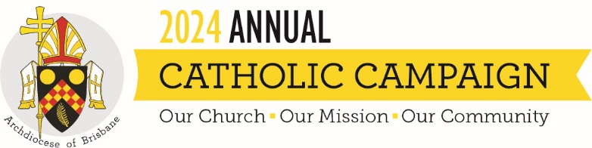
ANNUAL CATHOLIC CAMPAIGN 2024
Twentieth Sunday of Ordinary Time Year B

There isn’t much that human beings absolutely need for survival, but two of them are food and drink. We take them for granted, but without them we die. So when Jesus speaks of food and drink, as he does today, he’s speaking of life and death.
But he doesn’t just speak of food and drink: what he says is much stranger. He says he is the living bread, that the bread that he gives is his flesh “for the life of the world”. He also says that his “blood is real drink”. No wonder the early Christians were accused of being cannibals. But that’s not what Jesus means.
He says that if we need food and drink to survive, we need the right kind of food and drink not just to survive but to flourish; and the right kind of food and drink for human flourishing is his flesh and blood. He’s talking not just of life but of the fulness of life, for which bread and water aren’t enough. These days we hear and read a lot about what we should and shouldn’t eat and drink to be at our best; all kinds of diets appear, not just to help us lose weight but to have us at our best in other ways. Jesus isn’t proposing yet another diet; but he’s keen that we know what we have to eat and drink to come to the fulness of life which he offers. We have to eat his flesh and drink his blood. If we do that, he says, we will live forever – by which he means not so much endless life but the fulness of life. All of us long for that life, but sometimes we look for it in the wrong place, choosing the very thing that leads not to the fulness of life but to life as grim survival or even death.
The language Jesus speaks is clearly eucharistic. He speaks of the feast where, by the power of the Holy Spirit, the bread becomes his body and the wine becomes his blood. But he also implies that we become what we eat and drink. This is true in a biological sense: we do become what we eat and drink. It’s still truer in a theological sense: when we eat the body of the Lord, his flesh, and drink his blood, we become the body broken and the blood poured out for the life of the world. Because he doesn’t just mean body in some general sense: he means the body broken on the Cross. And he doesn’t just mean blood in some general sense: he means the blood poured out of the Cross. So we who eat the body broken at the eucharistic table are to become the body broken; and we who drink the blood at the eucharistic table are to become the blood poured out. The mystery of the Lord’s Cross becomes the truth of our life.
It's only against this background that we understand the full scope of the Annual Catholic Campaign. It’s a call to make a sacrifice to support the works of the Church; but the giving makes sense only in the context of us becoming the Lord’s sacrifice for the life of the world. You and I make a sacrifice to enable the Church to become the sacrifice. The contribution we make is ours, but the sacrifice is Christ’s; and his sacrifice is for the life of the world.
We see this clearly in the Mary MacKillop Catholic Education Fund which enables students from families who are struggling financially to receive a Catholic education so that they can taste the fulness of life, flourish not just survive. We see it in Centacare’s pastoral ministries which provide support for the victims of domestic violence and the homeless, care for families in strife, counselling for the troubled, chaplaincy in hospitals and ministry in prisons. These are areas where the power of Christ’s sacrifice is badly needed.
We see it too in the support for Holy Spirit Seminary, where numbers may be down but the costs are up. You can’t have the Catholic Church without the priesthood in one form or another; and that’s why the seminary matters. No less important is to care for men at the other end of the journey, by which I mean priests in retirement or suffering illness. That’s why the Priests Foundation is part of the Annual Catholic Campaign.
All of these are tax deductible. But this year we add two other appeals which aren’t tax deductible but are important. The first is the Annual Grants Program in support of grassroots ministries, mostly in parishes, and other outreach programs helping the Church to become more missionary. Then there is the Santa Teresa Spirituality Centre where we need to extend both the buildings and the program to make it more a powerhouse for the teaching of prayer in the Archdiocese. That’s high on the list of priorities.
So there you have six very practical ways in which the Church becomes what we eat and drink at the eucharistic table. From the Old Testament we have heard that wisdom has prepared a feast; and St Paul has urged us to be intelligent enough to recognise the will of the Lord. To be wise and intelligent is to eat and drink the right thing. The will of the Lord is that we eat the flesh of Jesus and drink his blood, so that we then become his sacrifice. That’s the whole point and the deeper meaning of the Annual Catholic Campaign and the appeals which it supports.

