Image | Headline | Text
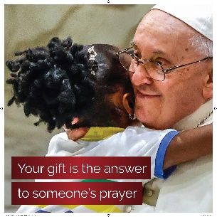 | Your gift is the answer to someone’s prayer | The Annual Catholic Campaign reminds us that we are part of the larger Church. When we work together, we support vital ministries and services, and we accomplish what we cannot do alone.
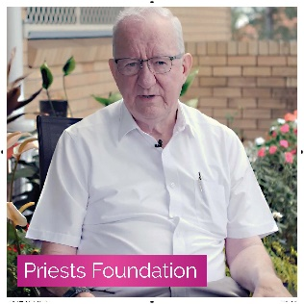 | Give our elderly and unwell priests the support they need | Your support helps our retired and infirm priests, who have dedicated their lives to meet the needs of your community. Through your gift, you ensure these men have a home and access to basic healthcare once they step out of active ministry.
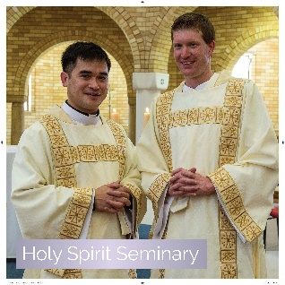 | Provide a home for priests in training | The Church will always need ordained leadership through the priesthood. With your gift, you invest in our seminarians, and ensure the future of our faith.
 | Provide a Catholic education and community to children in need | Your support enables students from families who are struggling financially to receive a Catholic education so that they can taste the fullness of life. You help them flourish despite life’s hardships.
 | Support those in your community in vulnerable circumstances | Your gift to support ministries within Centacare provides support for victims of domestic violence and the homeless, care for families in strife, counselling for the troubled, chaplaincy in hospitals and ministry in prisons.

