Image | Headline | Text
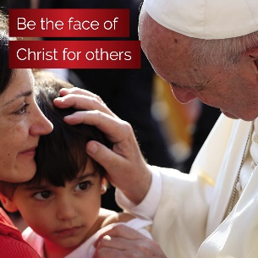 | Be the face of Christ for others | We are called to be the face, hands, and heart of Christ in our communities. Every day, God showers us with blessings so we will have gifts to share. Your gift to the Annual Catholic Campaign supports those in need.
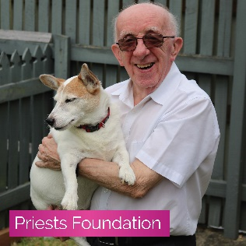 | Care for the ‘fathers’ of our faith | Through The Priests Foundation, you support our retired and unwell priests who have dedicated their lives to meeting human needs with the merciful love of God.
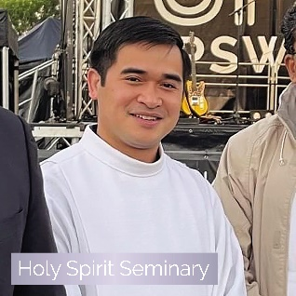 | Support the future of our faith | Holy Spirit Seminary trains our ordained leaders of the future. These men need to be formed to be the ministers of Christ’s mercy in our communities, and your support makes that possible.
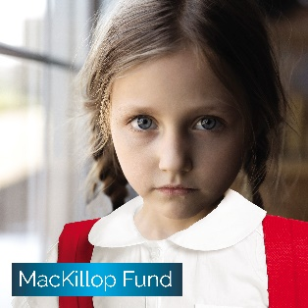 | Provide a Catholic school community to children in need | Your support provides bursaries for students whose families are facing financial hardship and at times even homelessness. You ensure these students have access to a quality Catholic education through our Brisbane Catholic Education schools.
 | Support those in your community in vulnerable circumstances | Centacare’s Pastoral Ministries provide support to families in distress and to victims of domestic violence, to those suffering mental illness and those in prison, to hospital chaplaincy, and to the disabled. Much of this work is hidden, but these ministries are an important outreach of the Church to people in real need.

