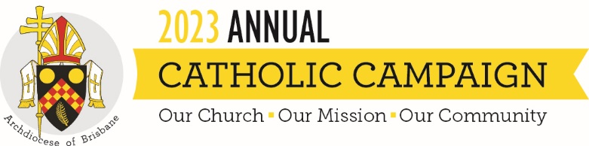
Campaign Weekend Script
The content below is intended to help you with content and ideas for announcing the campaign in your parish on campaign weekend. These are suggestions only, and you are free to change or add anything that you believe will resonate with your parishioners.

Good morning/afternoon
This year has been challenging and rewarding in many ways, and while there is much to worry over, there is also so much to be grateful for. Today, will hear a specially prepared homily from Archbishop Mark Coleridge, to share the importance of the Annual Catholic Campaign, and how we can continue to be the face of Christ for others in our community.
There are many who need our care, and this campaign reaches out to those who need our support most. I encourage you to support it this year.
The Annual Catholic Campaign reminds us that we are part of the larger Church. Our parishes work together to support vital ministries and services. Funds raised will support ministries that directly impact this parish, such as:
- training future priests,
- caring for elderly priests when they become frail and unwell,
- helping struggling families access a Catholic education and
- caring for those suffering physically and emotionally in our local community.
When making your gift, please put your donation inside the envelope provided [hold up brochure and show them how envelope is attached] so it remains separate from the parish collection. If you add your details to the envelope you will receive a tax receipt in the mail.
Over the past years, our parish has given generously and together we have made a lasting impact on the lives of so many people in our community.
Thank you for your generosity and for making sure our Church is here to help in times of need.

