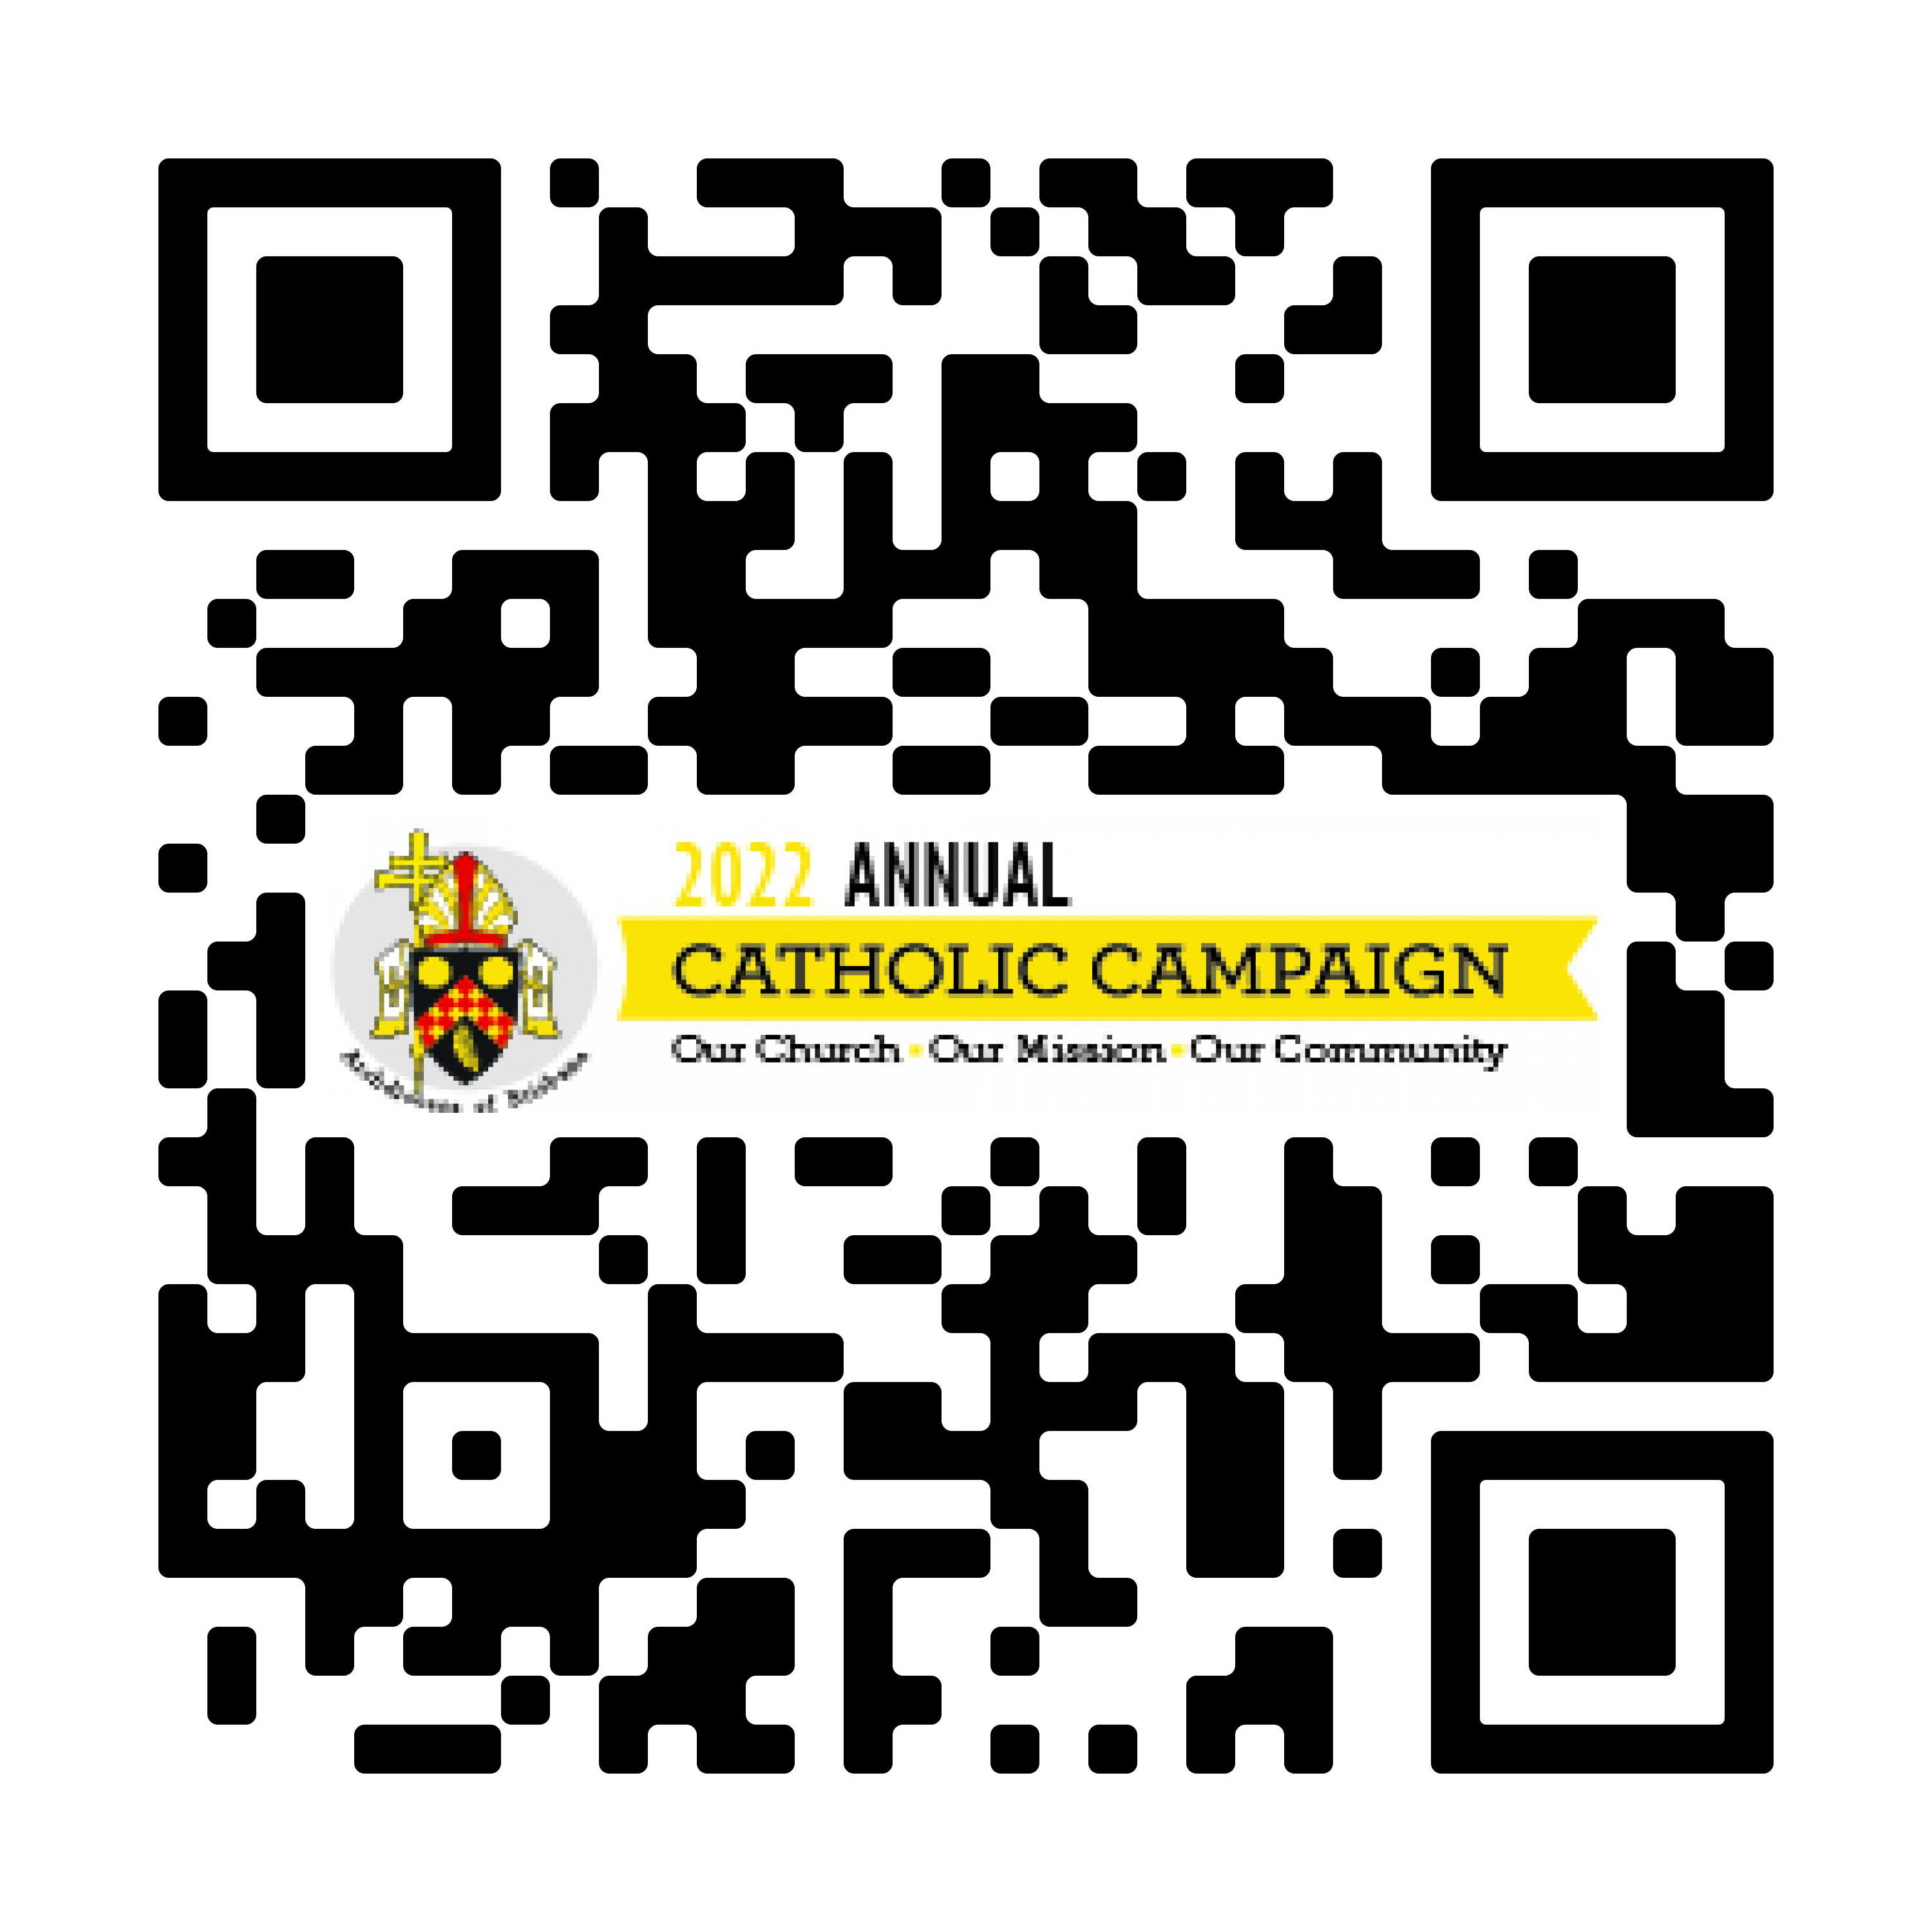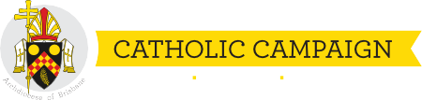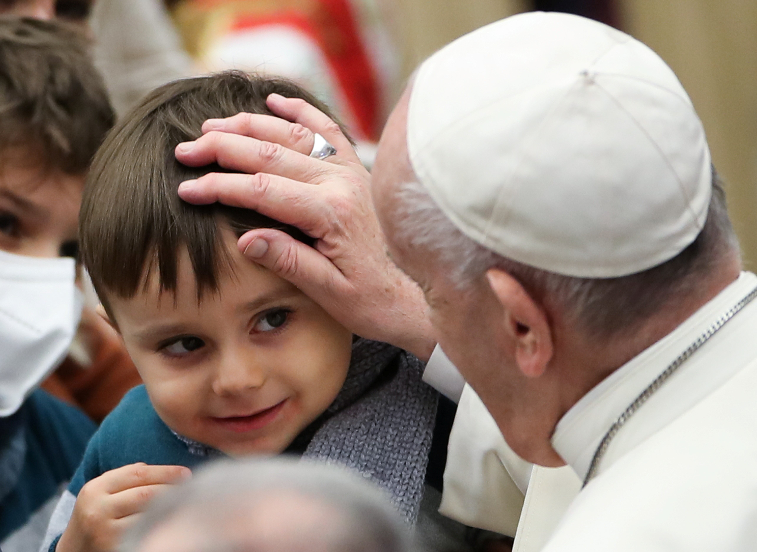Be the face of Christ for others

Thank you for your generous support of the Annual Catholic Campaign! Your gift helps educate our future priests, care for unwell priests, ensures children from families in hardship have access to Catholic education, and reaches out to our neighbours in vulnerable circumstances.
2021 ANNUAL

Our Church Our Mission Our Community

With your gift, you are the face, hands, and heart of Christ to those who need us most.

