Image | Headline | Text | Web link
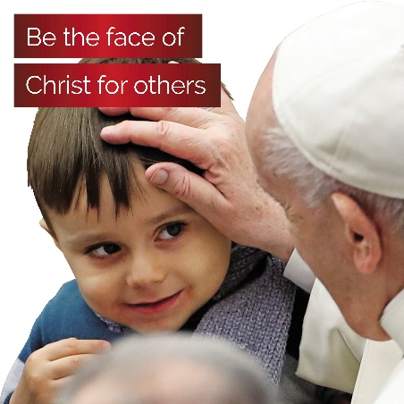 | Be the face of Christ for others | We are called to be the face, hands, and heart of Christ in our communities. Every day, God showers us with blessings so we will have gifts to share. Your gift to the Annual Catholic Campaign supports those in need. | catholicfoundation.org.au/catholic-campaign/
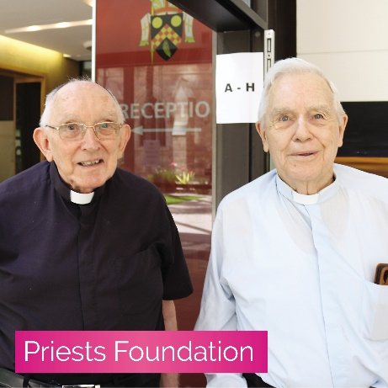 | Care for those who have cared for us | Your gift ensures our elderly priests have the support they need to retire with dignity; knowing they have a community of the faithful invested in their wellbeing. | catholicfoundation.org.au/catholic-campaign/
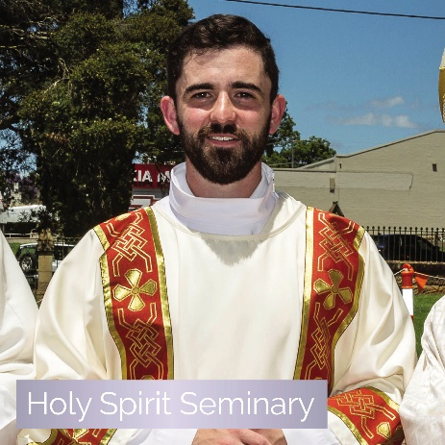 | Support future priests in their formation | Your support gives future priests the support they need to answer God’s call and stay the course. With your gift, you ensure the future of our faith. | catholicfoundation.org.au/catholic-campaign/
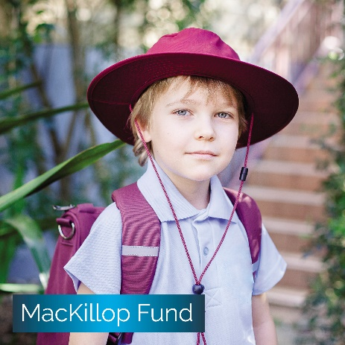 | Provide a Catholic school community to children in need | You give children living in hardship the love and care of a Catholic school community when they need support most. With your gift, these young people have access to a quality Catholic education. | catholicfoundation.org.au/catholic-campaign/
 | Create a world where all people in your community are supported to thrive | Your support enables Centacare to reach out in compassion through services like mental health support, domestic violence support, hospital chaplaincy and prison ministry. | catholicfoundation.org.au/catholic-campaign/

