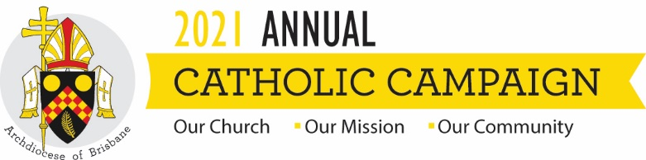

THE ANNUAL CATHOLIC CAMPAIGN 2021
Twentieth Sunday of the Year – Year B

The whole of biblical religion begins with the call to listen. Each day Jewish people recite the words of the Book of Deuteronomy which Jesus echoes in the Gospel: “Listen Israel: the Lord God is our God, the Lord alone”. To listen was to be blessed and to become a blessing for others. So too each day the Christian disciple is called to listen to the words of Jesus who communicates with us as much now as he did to the disciples when he walked the earth.
Listening is harder than it sounds – in part because there’s usually so much noise within us and around us that we simply can’t hear. But another reason why listening to Jesus is hard is that he often speaks words we don’t expect or want to hear. He says some strange things which, if we were to listen and obey, would take us into some strange places. Yet the disciple who doesn’t just hear but really listens is prepared to follow wherever the Lord leads, however strange it may be.
In today’s Gospel, we hear of some who stopped following Jesus because his language became just too strange. He had been speaking of eating his flesh and drinking his blood, to which some replied, “This is intolerable language” – and you can understand why. What Jesus says about his body and blood is extraordinary language, strange by any reckoning. So they say, “Enough!” and wander off elsewhere, looking to follow another who speaks in ways less strange.
But not everyone wanders off; some stay – among them the Twelve. “Do you also want to go away?” Jesus asks them. Silence: but then Peter speaks up. “Lord, to whom can we go?” Note he doesn’t say that the words of Jesus are perfectly reasonable and acceptable; he too is baffled by what he’s heard. The language of Jesus is strange, yes, but not for Peter intolerable. He recognises that, however strange they may be, these are “the words of eternal life”. The blessing comes but in ways we don’t expect. The way home to Paradise is strange – so strange in fact that it will lead them, following Jesus, onto the dark mountain of Calvary. But the blessing will come and lead them into the light of Easter.
Faith is the name of the recognition to which Peter comes: “We have come to believe and know that you are the Holy One of God”. The Twelve have come to see the truth of who Jesus is; and only faith can reveal that truth. Once faith opens the eyes to that truth the disciples come to knowledge; they know that the words of Jesus, however strange, are utterly true and trustworthy. Therefore, they stay with him and follow him wherever he leads.
The Annual Catholic Campaign is all about listening to the words of Jesus, “the Holy One of God”, trusting what we hear and following where he leads – becoming more and more like the Master as we go, until we become so like him that people see Jesus in us. It is to be blessed and to become a blessing in turn.
The Campaign focuses on four different ways of doing what Jesus does. First, the MacKillop Fund which provides Catholic education bursaries to children of families suffering hardship, especially in this time of pandemic. Second, Holy Spirit Seminary which provides formation for our future priests who will need strong preparation for the ministry of leadership that awaits them in changing times. Third, the Priests Foundation which supports the retired, elderly and ailing priests who have spent their lives in service of God’s people and who remain a vital part of the ecology of the Archdiocese. And fourth, Centacare’s Pastoral Ministries which reach out in compassion through services like domestic violence support, psychiatric counselling, family support, hospital chaplaincy and prison ministry – all of which are facing new pressures as a result of COVID-19.
Each of these works is a powerful sign of Christ who walks with us on the way, who knows our needs and enters into our suffering, the Lord who bears our burdens and heals our wounds. So I ask you today to support the Annual Catholic Campaign in this strange landscape through which we are passing where we’re all feeling the pinch in one way or another. You may even want to consider making a regular monthly gift of an amount which means something to you. Every dollar you give will be carefully spent and will be spent for the purposes I’ve mentioned; and it will make a real difference to people who are doing it hard and need to know that the Lord Jesus is close to them.
This time of COVID-19 has made us focus on what really matters. We’ve had to work out what’s really important in the midst of all the stuff that fills our life. The Annual Catholic Campaign is one way of focusing on what really matters, which in the end means focusing on Jesus and listening to the strange and wonderful words he speaks – not just hearing but listening. His are “the words of eternal life”, the words of him who says, “Come you blessed of my Father: inherit the Kingdom prepared for you (Matt 25:34), for…as long as you did this to one of these, the least of my brothers and sisters, you did it to me” (Matt 25:40). We focus on the least in order to focus on Jesus and follow him – because “to whom else can we go?” He is the only one who can lead us home.

