Image | Headline | Text | Web link
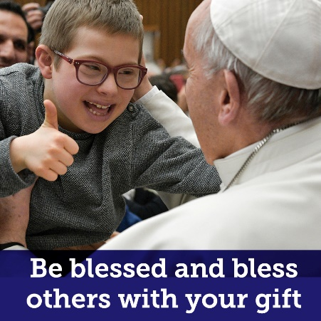 | A powerful sign of our faith in action | As Catholics, we are called to care for our neighbours. Your gift to support the Annual Catholic Campaign is a joyous expression of your love and care for those in need. | https://catholicfoundation.org.au/catholic-campaign/
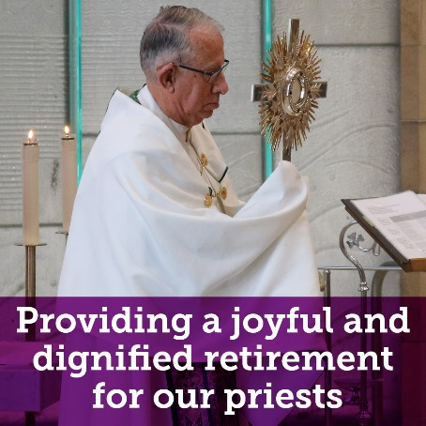 | Care for those who have cared for us | Your gift provides more than material comfort. It tells our retired priests that they are not forgotten; that they are carried in our prayers; that their years in service have borne fruit in our hearts. | https://catholicfoundation.org.au/catholic-campaign/
 | Bring the light of the Gospel to every corner of  the Archdiocese | With your support of Holy Spirit Seminary, you provide a home for the formation of future priests for our faith. | https://catholicfoundation.org.au/catholic-campaign/
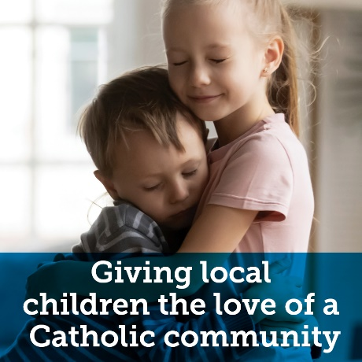 | Encourage children in need to see their learning through a faithful lens | St Mary of the Cross MacKillop believed that every child deserves a faith-based education, especially those from families living in hardship. With your gift, you continue her legacy of care for vulnerable children. | https://catholicfoundation.org.au/catholic-campaign/
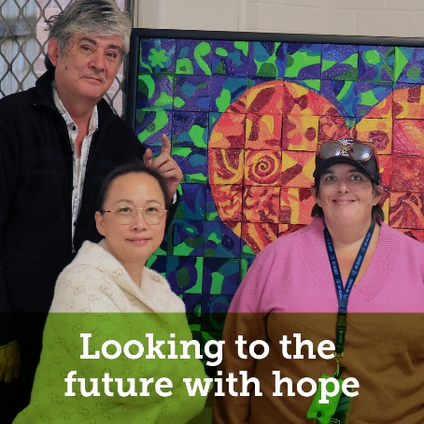 | Create a world where people in your community are supported to thrive | Your support enables Centacare to reach out in compassion through services like mental health support, domestic violence support, hospital chaplaincy and prison ministry. | https://catholicfoundation.org.au/catholic-campaign/

