You can download the 45 second promotional video from DropBox and save it to your computer using the instructions below:
Click on the link to DropBox: https://www.dropbox.com/s/ezf5dwm1tjmz5ci/ACC%20Promo%20NEW.mp4?dl=0
You do not need to sign in or have an account with dropbox to download the video.
On the right hand side, click on the Download button:
Select Direct Download:
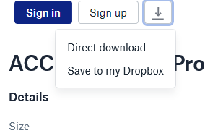
The file should automatically start downloading:
- if you are using Google Chrome it will show up in the bottom left hand corner from where you can save it on your computer
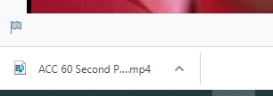
- If you are using Microsoft edge, it will ask you if you want to open or save the file – select save
